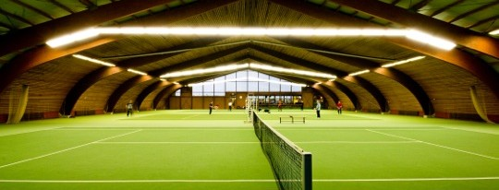

REGISTRATION FORM: DUTCH BOWL by TEN-PRO (15-22 MAY 2022)

Name of player:
Boy/Girl :
Date of Birth :

Representing the country:

NOTE: Registration for participating in two categories is also possible in that case we guaranteed 8 matches! (in your own category plus one EXTRA older age category) * See regulations

Please indicate: Play in one or in two category ………….

Tel. number :
Mobile nr. :

E-mail (Parent) :

Name of tennis club:
E-mail of tennis club:
Name of your coach :
E-mail of your coach :

Favorite player:
You play with (racket):

Training hours weekly:
Private training :
Training in group :
Physical training :
Mental training :

Current ranking my age:
Main results:

Your greatest wish:
Certificate of health:

By sending this registration form we declare that we have read and accept all the terms and conditions of TEN-PRO Global Junior Tour unconditionally and also that our son/daughter/player ............................................... is in perfect health and has the permission of his/her parents to take part in this tournament. We also agree that Ten-Pro have permission to make free use of all photos and films of our son/daughter/player (For Social Media of TEN-PRO or by partnership website).

TO COMPLETE THIS APLLICATION YOU ARE REQUIRED TO ENCLOSE A COPY OF PLAYER ID OR PASSPORT!

To participate, please fill in the enclosed form and return it by e-mail to proglobus@live.nl f.a.o. Goran Novakovic

Powered by:

TEN-PRO Global Junior Tour / Mob.: +31 (6) 22 11 88 57 / Website: www.ten-pro.net / FB: Ten-Pro Global Junior Tour / Insta: Ten-Pro Global Junio Tour / Twitter: @TenProGlobaljr

