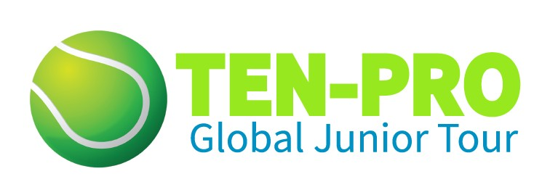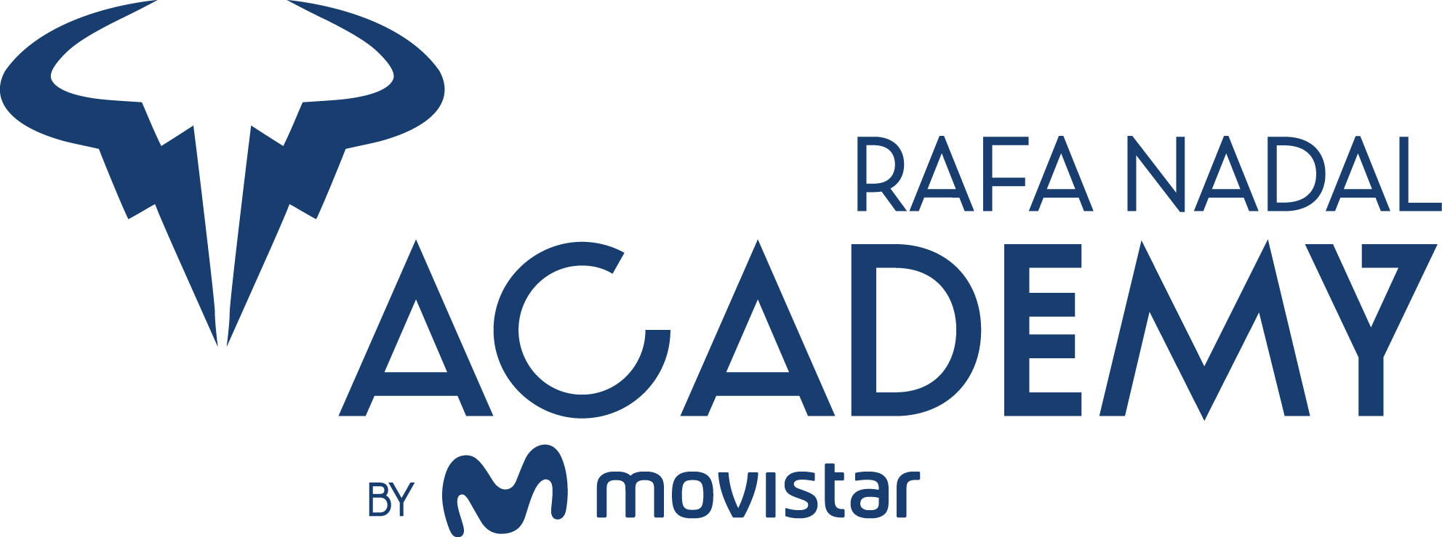

TEN-PRO at RAFA NADAL ACADEMY, 2 - 8 November 2020

U10 - U11 - U12 – U13 – U14 – U15

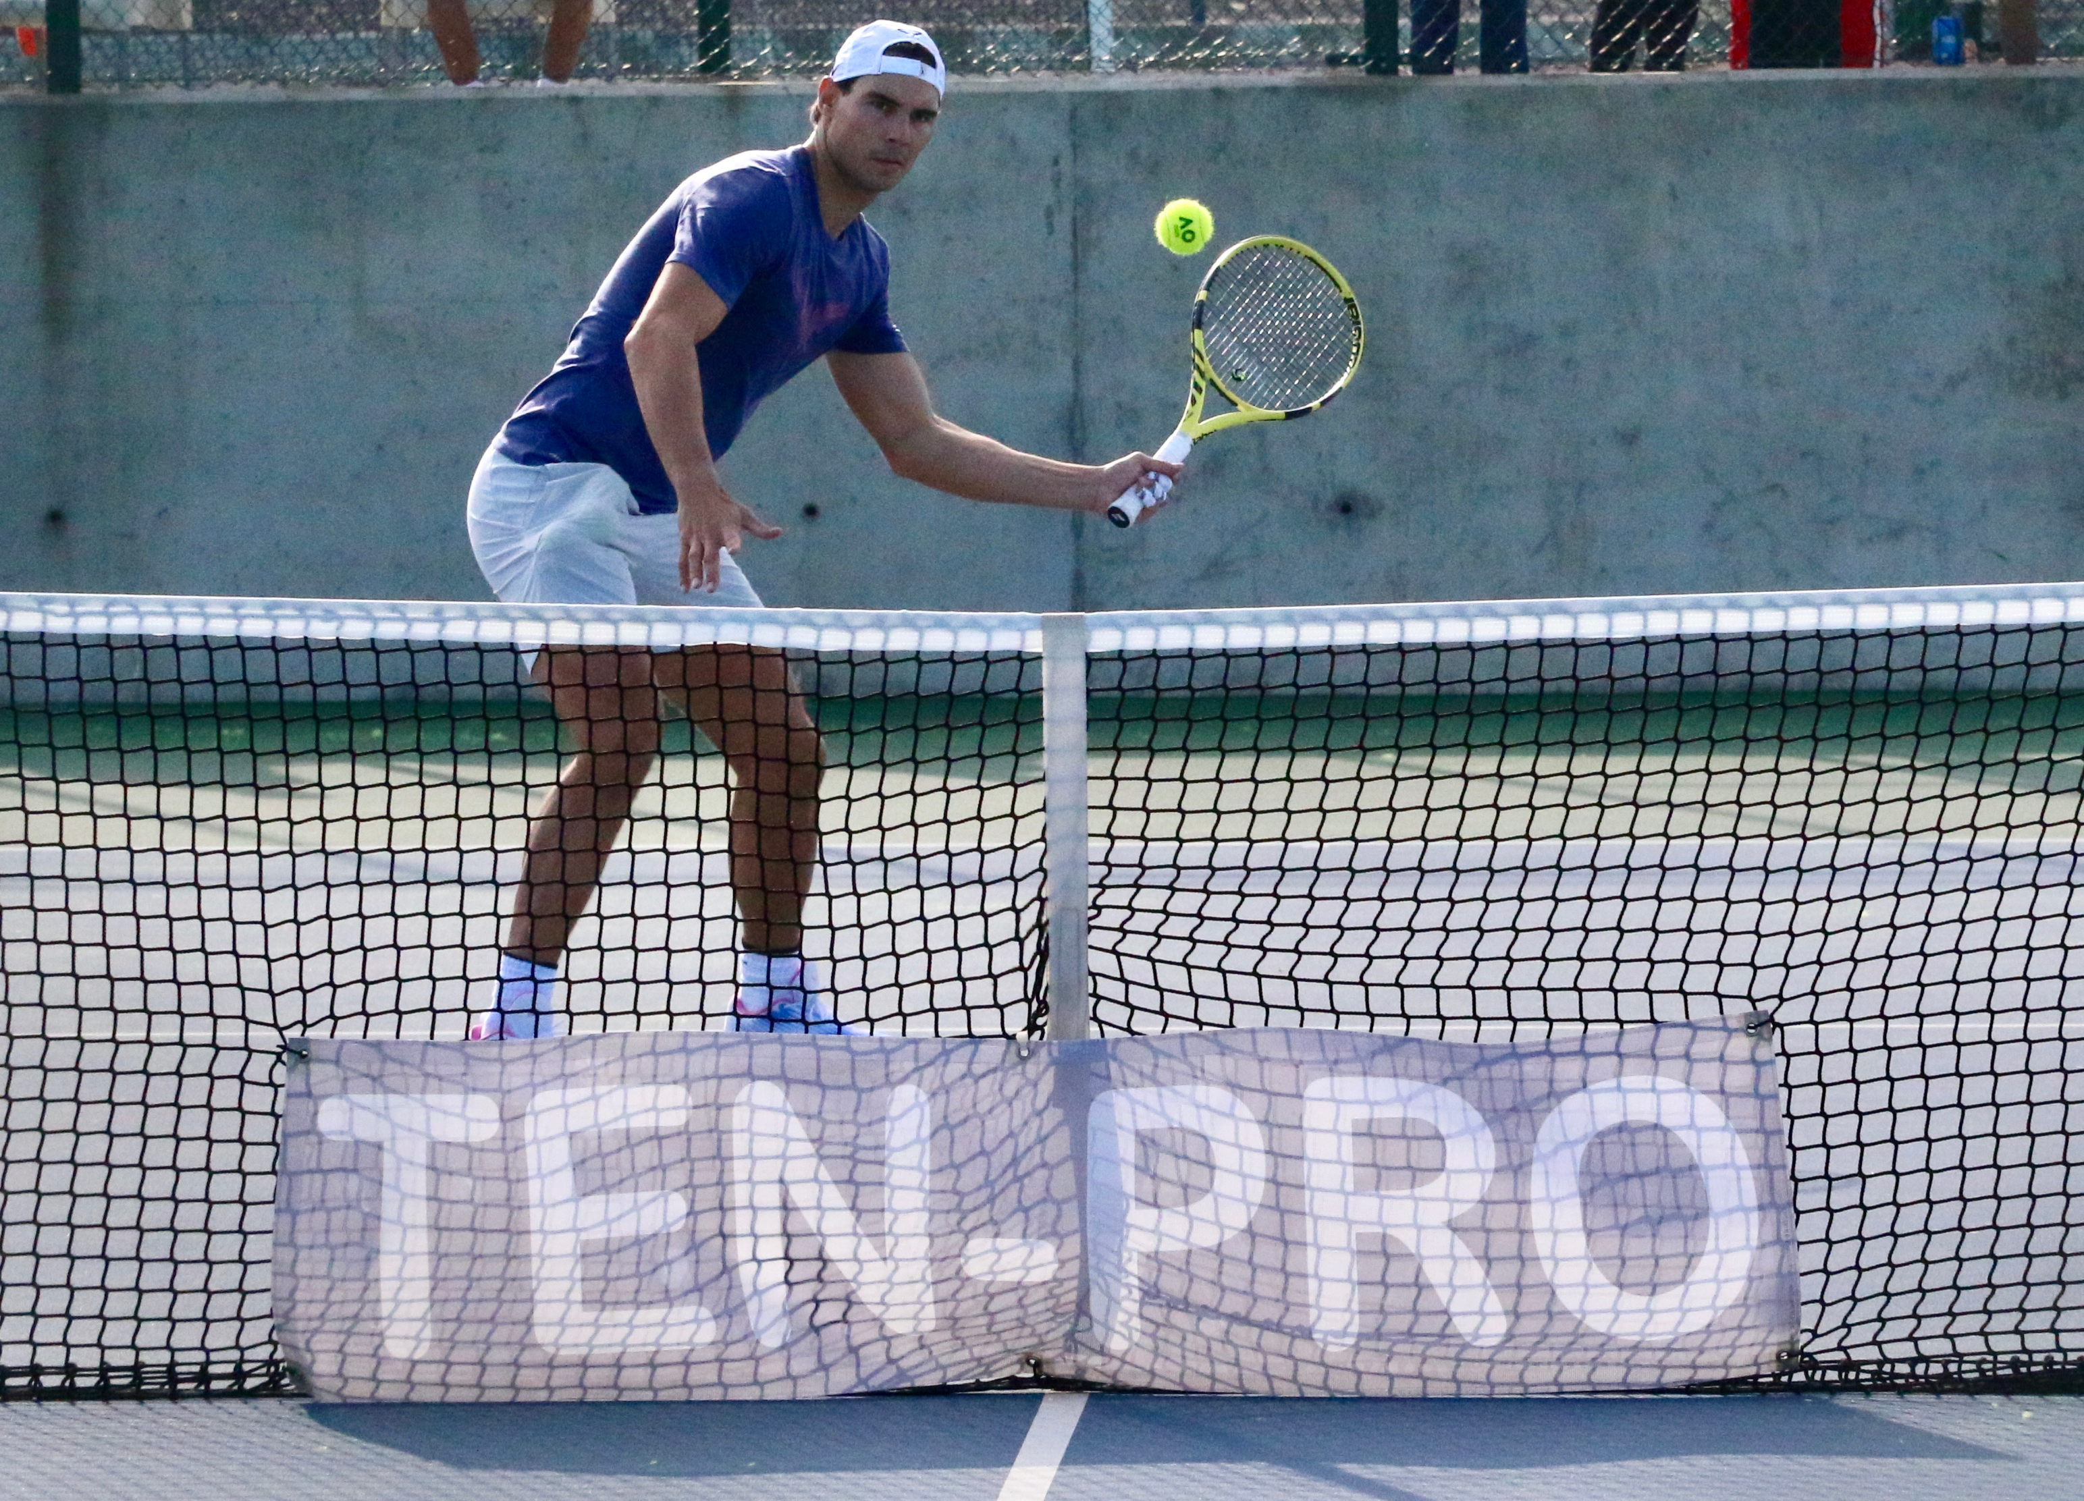

Special invitation to participate on the TEN-PRO Global Junior Tour at RAFA NADAL Academy

IMPORTANT INFORMATION

Monday 2th to Sunday 8th November 2020

4 or 8 MATCHES GUARANTEED FOR EVERY PARTICIPANT! * See regulations

Organizers:
www.ten-pro.net

Contact & Registration:
proglobus@live.nl
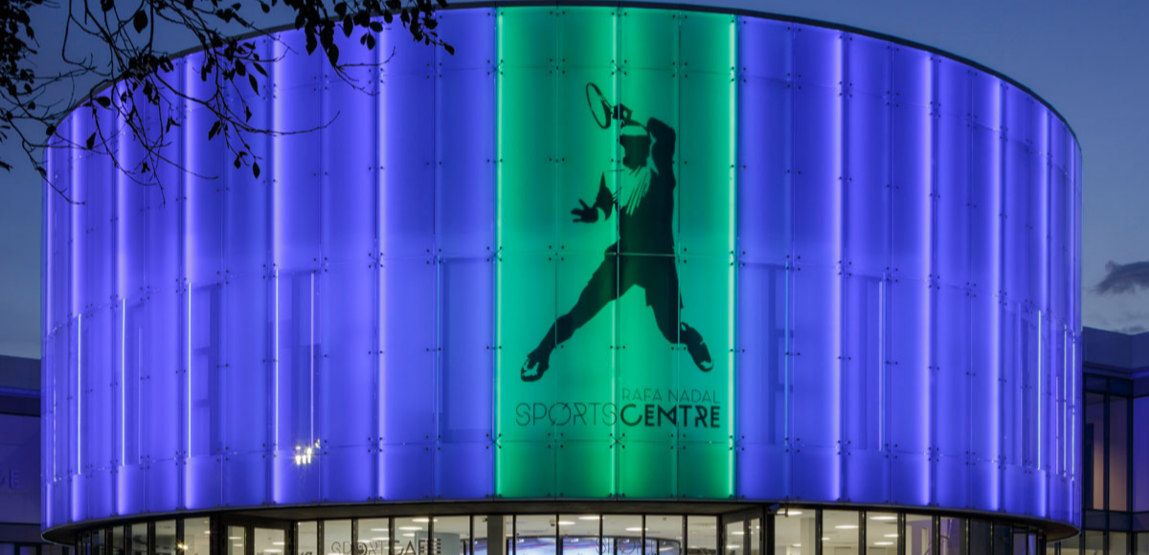

Rafa Nadal Tennis Academy is situated on a fantastic location in Mallorca, Spain with new “ State of the art ” tennis complex and with 26 regulation tennis courts of different surfaces (Clay, Greenset), outdoor and indoor, Fitness Centre with all the latest equipment, 2 swimming pools; one outdoor and one indoor plus much, much more….

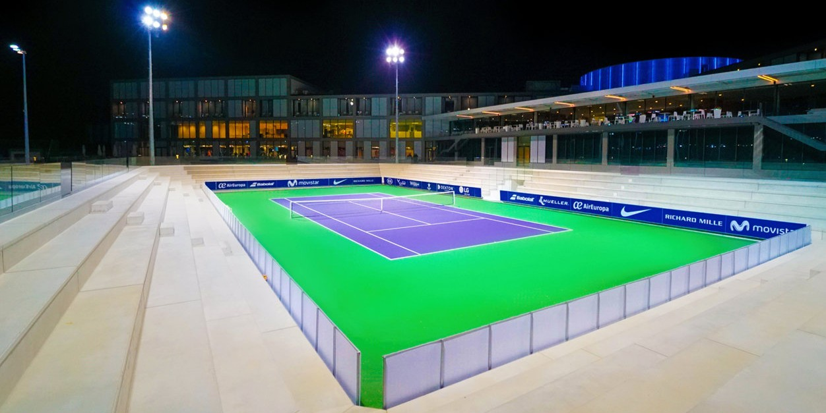

Rafa Nadal Academy opens its doors to young players to train with the method that has led Rafa to be number one, with guarantees of being surrounded by the best coaches and the best technical team in the tennis’ field. All this in a space thought for them, in an integral campus with the best facilities and high technology applied to sports. Maximize your strengths; minimize your weaknesses with the training techniques of Rafa Nadal and his team.

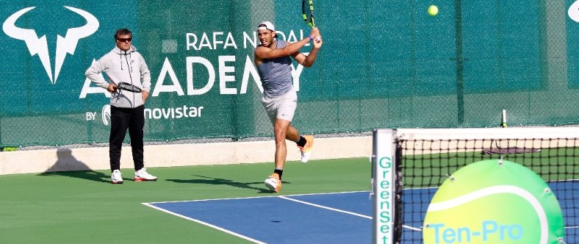

TEN-PRO & RAFA NADAL ACADEMY invite you to participate at

An international tennis tournament for worldwide highly talented boys and girls, in categories U10 up to U15, Six separate age category competitions at the same time, from born 2005 up to 2012.

TOURNAMENTS INFORMATION!

This outdoor tournament will be held at RAFA NADAL ACADEMY by Movistar, Mallorca Spain
Address: Torre dels Enagistes, Manacor, Mallorca 07500 Illes Balears, Spain

WE GUARANTEE EVERY PLAYER 4 OR 8 MATCHES! *see regulations

NOTE: Registration for participating in two categories is possible! in that case we guaranteed 8 matches! (in your own category plus an one EXTRA older age category).This request should be send to proglobus@live.nl for the attention of Goran Novakovic.

TOURNAMENTS RESULTS ARE COUNTED BY UTR (Universal Tennis Rating)
https://www.myutr.com/

TEN-PRO RANKING SYSTEM! “SCORE YOUR POINTS AND EARN YOUR REWARD”
http://www.ten-pro.nl/ranking-system/
COACHING ON-COURT ALLOWED!

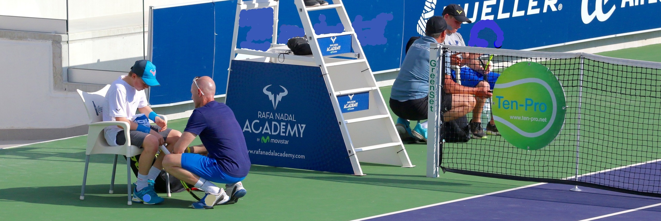

TEN-PRO & PlaySight tennis video system

Get more from your game with PlaySight live streaming and video review. Analyze and improve like the pros.

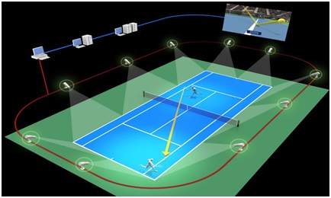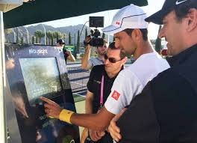

- LIFT YOUR GAME TO ANOTHER LEVEL –

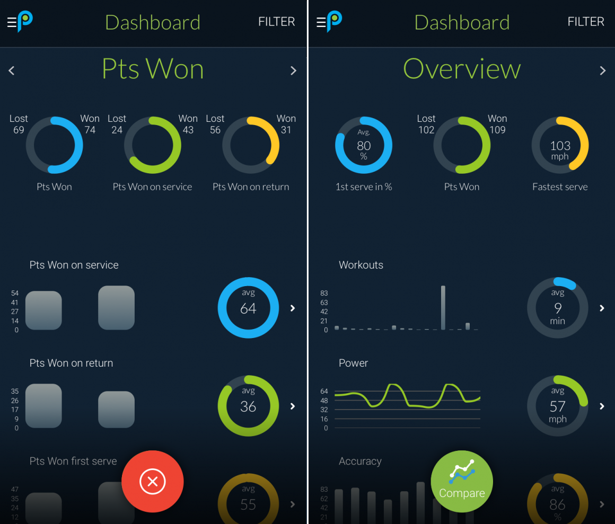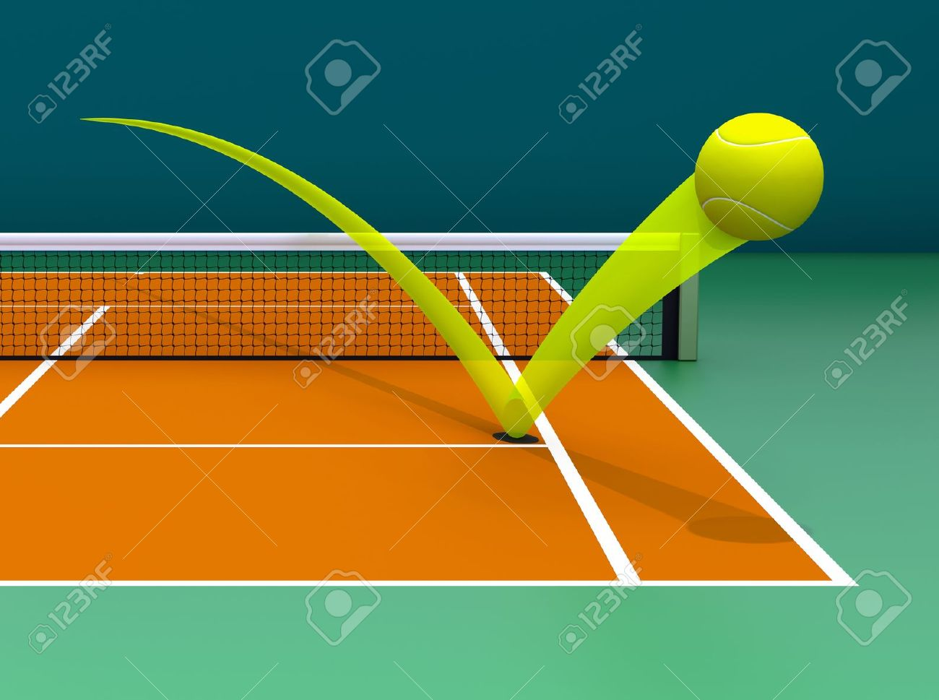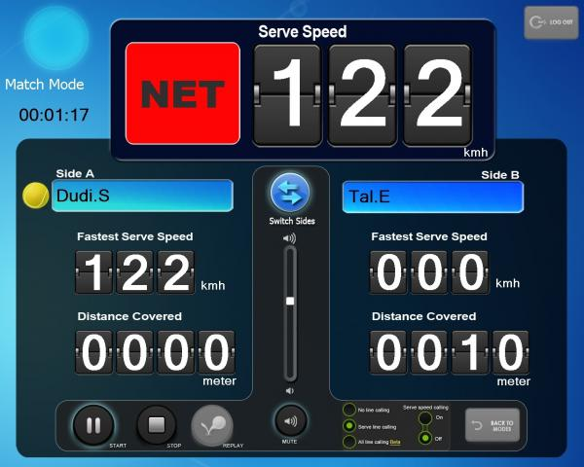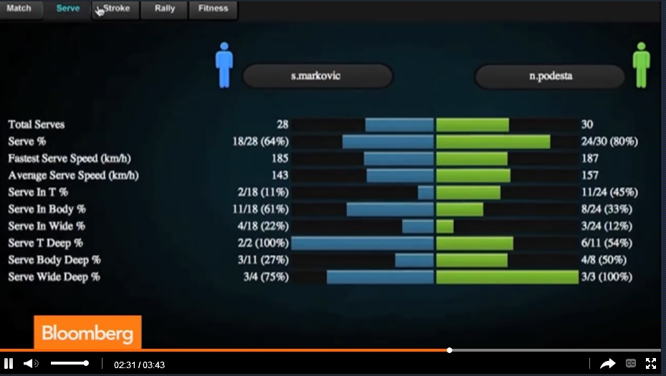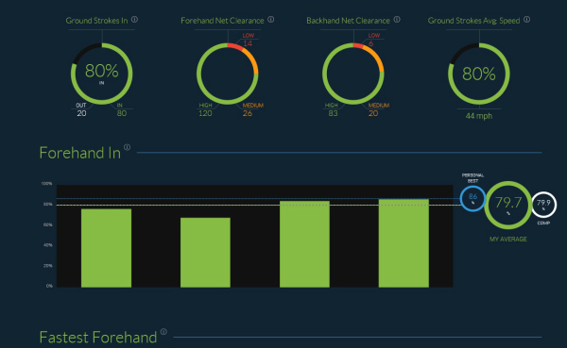

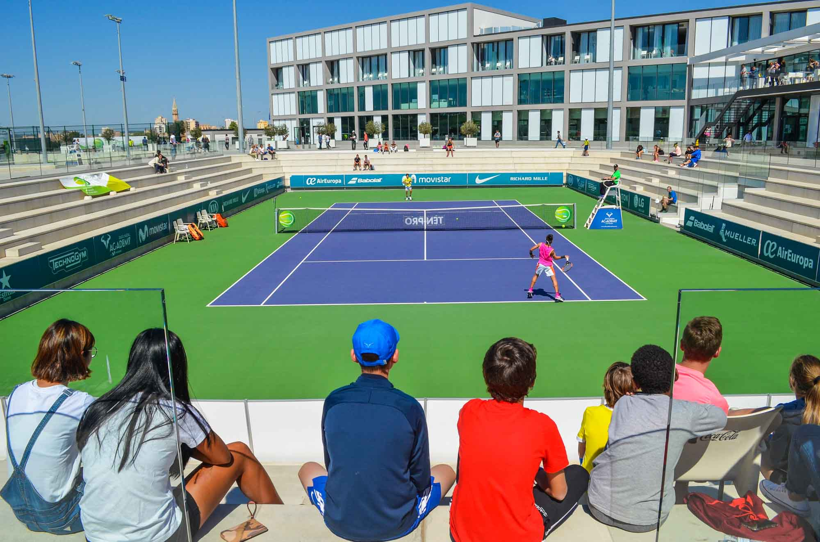

TRAINING CAMP
In order to have your players prepared for the upcoming tournament everyone can choose the options which suits their needs. Players can choose to join the camp or to book individual sessions with Rafa Nadal Academy coaches. With these options we will have the majority of your needs covered.

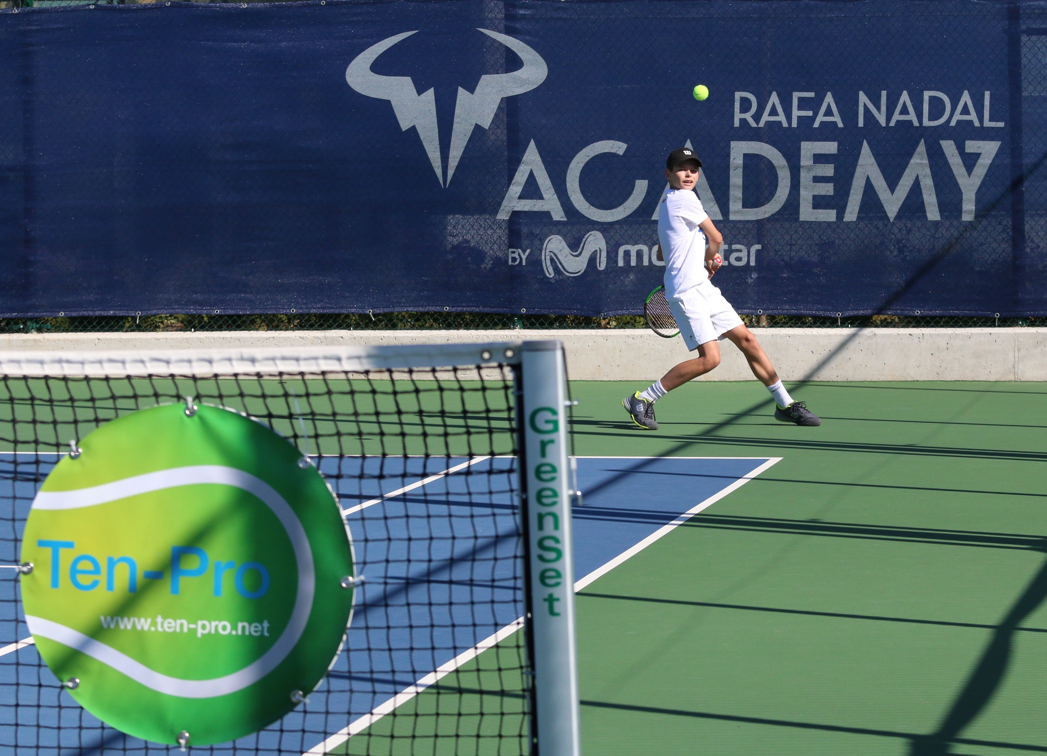
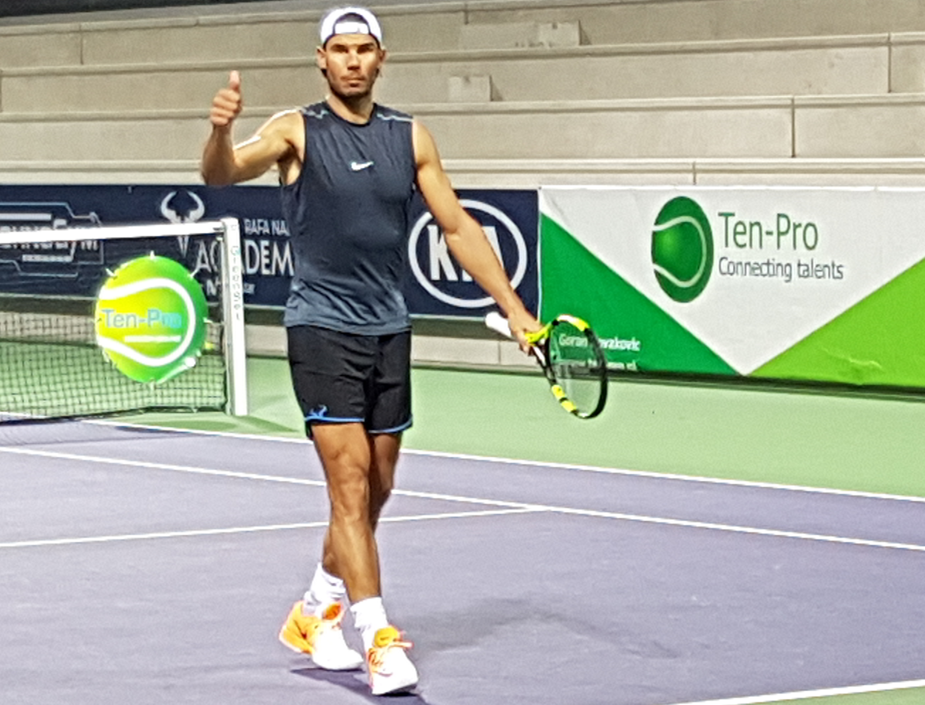

Every player on our tour can score points for the results they achieve in our tournaments. At the end of the year this will result in a TEN-PRO ranking. With your ranking you can earn your reward such as a trainingsweek at Rafa Nadal Academy, a sponsor contract, tennis materials and many other prizes from our proud sponsors and partners.

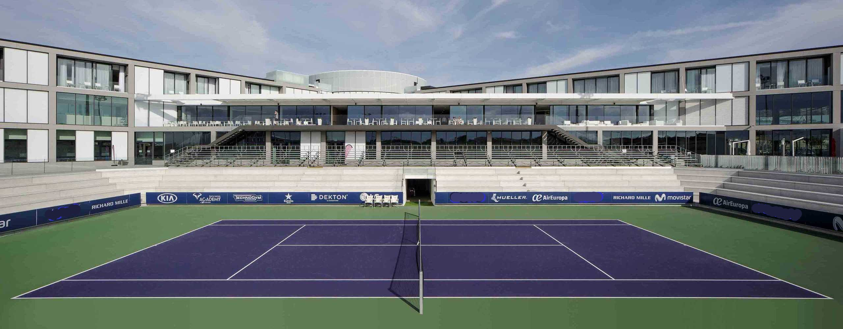

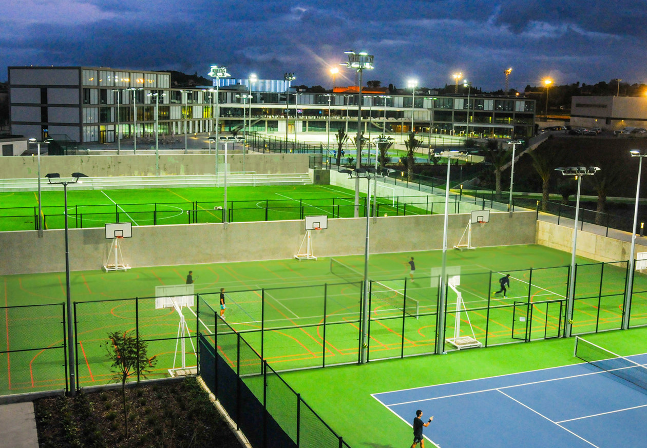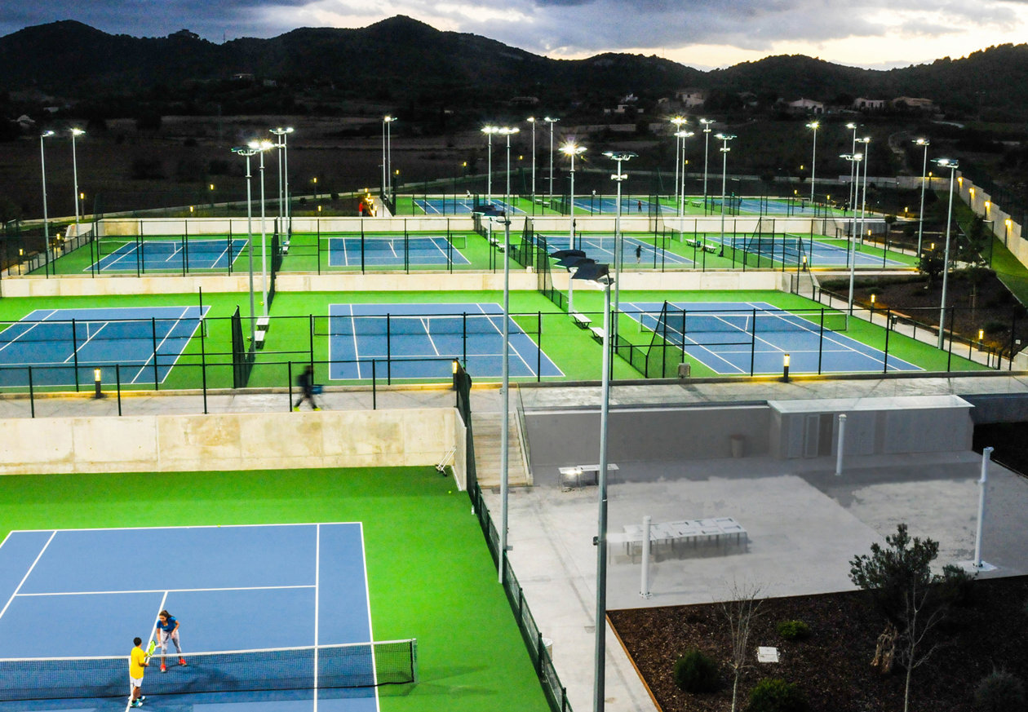
The competition regulations, tennis camp, schedules and other useful information about the tournament can be found on our website www.ten-pro.net , we will provide additional information about the tennis accommodation, hotels and other local facilities. Young top talents in tennis will be able to compete and learn from each other.

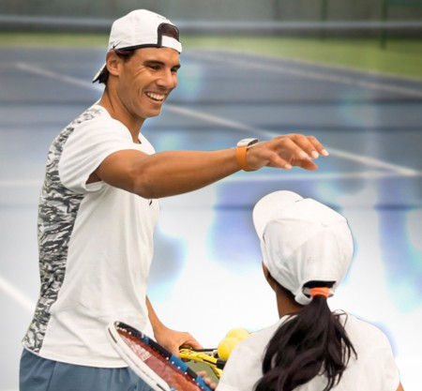 IT’S ALL ABOUT DEVELOPMENT

During the tournament parents and coaches will also have a chance to learn, experience tennis talents development and enjoy their stay at the beautiful and sunny Mallorca!

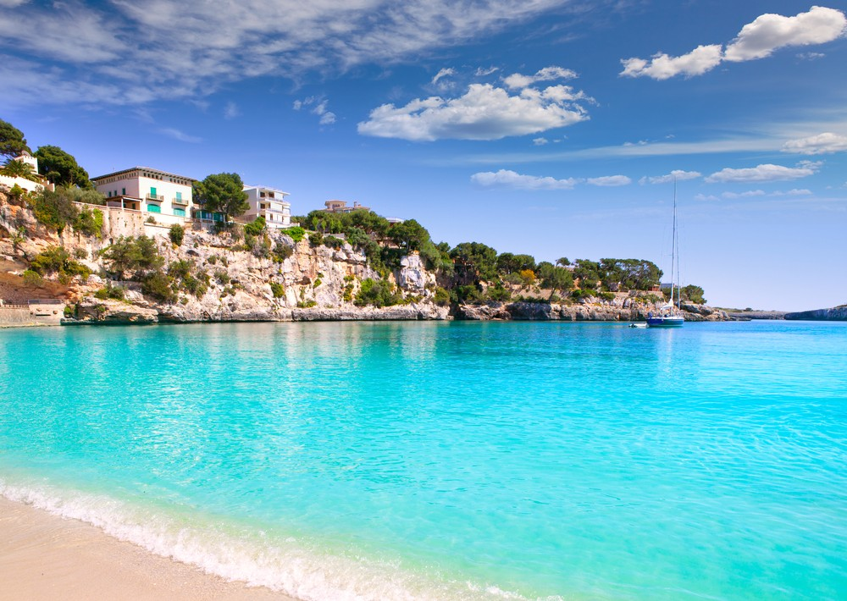

There are great prizes to win, such as:

- TEN-PRO tournament T- shirt for each participant!
- RAFA NADAL Academy trophies and package for the winners (1,2 and 3rd place)
- TEN-PRO package for the winners.
- TEN-PRO Global Junior Tour certificate for all participants.
- Possibility of Wild Card for many other tournaments.
- Furthermore it will create an outstanding support base in obtaining the perfect sponsor agreement!
- And other prizes from our proud sponsors and partners.

We kindly ask you to send this letter with invitation to your best tennis players, born from 2005 up to and 2012. We hope to receive as many applications, from talented players, as possible because together we can make this a fantastic and worthwhile tournament!

To participate, please fill in the enclosed form and return it by e-mail to proglobus@live.nl f.a.o. Goran Novakovic. The closing date for registration is fixed on October 26th 2020 at 14.00. Providing the maximum number of players hasn’t reached yet at that time!

For more information we refer you to the following site: www.ten-pro.net

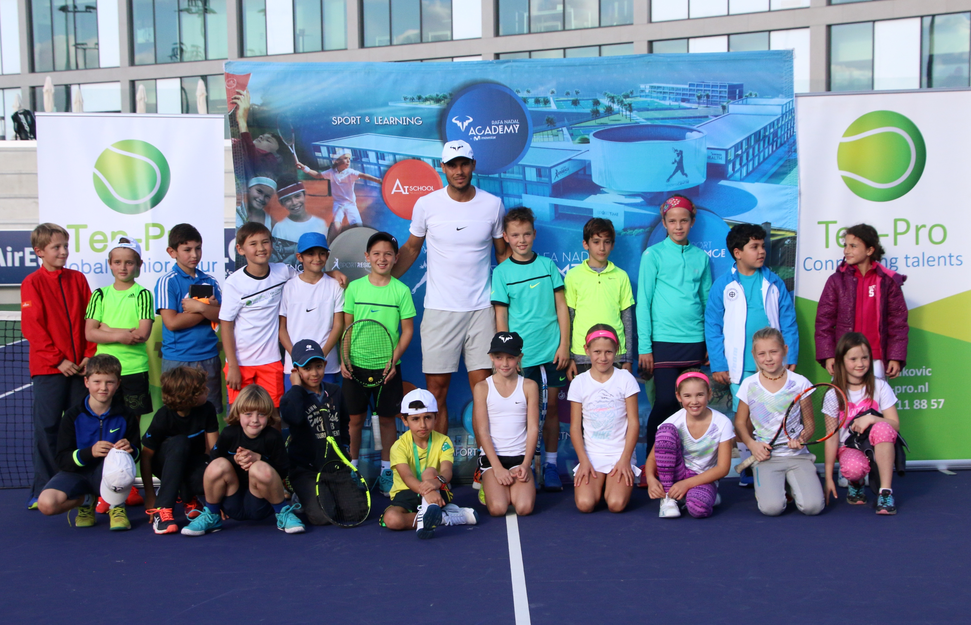
With your participation we will make this a fantastic event!

With kind regards,

Goran Novakovic Tournament Director

&

TEN-PRO Global Junior Tour / Mob.: +31 (6) 22 11 88 57 / Website: www.ten-pro.net / FB: Ten-Pro Global Junior Tour / Insta: Ten-Pro Global Junior Tour / Twitter: @TenProGlobaljr

