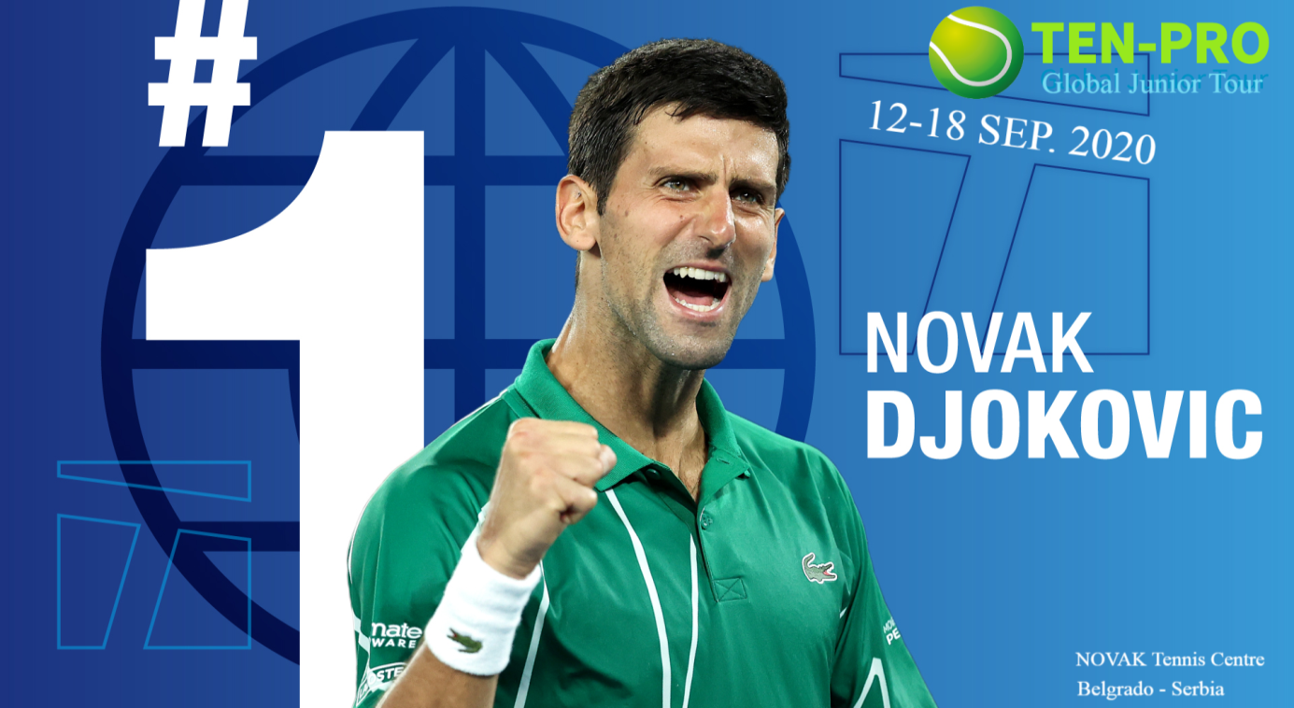

FACTSHEET NOVAK DJOKOVIC by TEN-PRO Global Junior Tour

Date : Saturday 12th up to and including Friday 18th September 2020

Location : NOVAK Tennis Center

Address : Tadeuša Košćuška 63a, Beograd, Serbia

Tournament organisation : TEN-PRO Global Junior Tour & NOVAK Tennis Center

Tournament director : Goran Novakovic (Tel. + 31 6 2211 8857 – WhatsApp)

Tournament planner : Sandra Voorwerk

Tournament desk : G.Koerselman-Meulman & M.H. Blankvoort

Marketing & communication: Carina Kaak

Head referee : Gerwin Gruben & Alex Willems

4 or 8 MATCHES GUARANTEED FOR EVERY PARTICIPANT ! * see regulations

Tournament structure:

The TEN-PRO organizes NOVAK DJOKOVIC by TEN-PRO Global Junior Tour for the age categories U10, U11, U12, U13, U14 and U15 (born 2005 up to and 2012) in both competition (Boys and Girls).

We guarantee every player a minimum of 4 or 8 single matches in the tournament! * See general regulation
NOTE: Registration for participating in two categories is also possible in that case we guaranteed 8 matches! (in your own category plus one EXTRA older age category). This request should be send to proglobus@live.nl for the attention of Goran Novakovic.

Results:
The tournament results are counted by UTR (Universal Tennis Rating) https://universaltennis.com/
The tournament results are counted by TEN-PRO RANKING SYSTEM " Score your points and earn your reward " www.ten-pro.net/ranking-system/

ON-COURT COACHING:
On-Court coaching is allowed during the tournament (In the practice this means coach or parent as a coach is allowed to come on court during a changeover once per set, only at the end of a set, maximum of 2 minutes).

During a match, a player can request her coach at the following times:
Once per set (Only at the end of a set)
a) Requests must be made to the Supervisor or Chair Umpire.
b) Maximum time allowed is 120 seconds (two minute).
c) Must leave the court immediately upon the Supervisor or Chair Umpire announcing “Time”.
d) In case of any violation of time Coaches may be penalized in accordance
to the Ten-Pro Penalty Point system. Or may result in his/her on-court coaching
privileges being removed.
e) For the rest of the match verbal or gesticulated coaching during the match is not permitted and can lead to violation of the rules (PPS: violation of the rules, coaching outside On-Court coaching time).

By delay:
If delayed please make direct contact with Ten-Pro (+ 31 6 2211 8857 - WhatsApp)
Max. total number of participants: 300

Location:
NOVAK Tennis Center

Proof of identity:
Each participant must be in possession of a valid passport (or identity card) and must show this to the tournament leaders when signing in.

Play rules:
All matches will be played for 2 won sets, a tie break will be played with the score at 6-6
By the score 40:40 (deuce) Sudden Death Point will decide it winner of gem, the returner chooses the side.
There will be matches to decide the 3rd and 4th places.
The “followed-by” system will be used during tournament.

The openings ceremony:
The openings ceremony will take place on Friday the 11th September 2020 at 18.00 o’clock at NOVAK Tennis Center. We ask all players, parents and coaches to be present at the ceremony.

Check in:
All participants are required to check in with the tournament leaders directly on arrival.
A participant has to report at the desk immediately after having arrived at the tennis courts and this should be done at least 30 minutes before the start of the match.

The draw:
The draw will take place per age group, at the latest on the day before the first playing day for that age group. The outcome from the draw, the start times for the first round and the court order of play for each day of play will be published on www.tournamentsoftware.com on www.ten-pro.net and on tennis club site.

Warming up and training:
After consultation with the organisation.

Tennis balls:
Matches will be played with regular all courts balls. Warming up balls will not be provided by the organisation.

Type of court:
The matches will be played on clay and hard courts (depending on the age category)

Rules of conduct:
The PPS “punishment points system” will be used *see Players instruction.

Code of conduct:
We respectfully but specifically request that the changing rooms are kept as clean and tidy as possible during the tournament. TEN-PRO and NOVAK Centre will hold participants responsible for any damage to the accommodation incurred by them (including damage and littering).

Clothing:
During the competition tennis clothing is required.

Physical and legal condition:
We will specifically remind you that it is the responsibility of the participant to ensure that they are fit and healthy. You can only play if you are in a good state of health.

Each player individually is responsible for their own insurance during the tournament.
TEN-PRO Global Junior Tour as the organizer can not be held responsible in any case!

Players themselves are totally responsible for organizing of this travel, accommodation insurance, visa (if necessary) and all other costs associated with this tournament.

TEN-PRO is excluded in case of any misuse of this above-mentioned.

Entry fees:
The entry fee is € 95,00 per participant (per category). Participation is only possible if the parent/guardian agrees to the method of payment and that the payment is made to Ten-Pro within 5 days after being requested.

Hotel:
The TEN-PRO at NOVAK Tennis Centre have a official players accommodations. During the tournament those hotel-s offers the players accommodation at a special rate for an overnight. For more information see: www.ten-pro.net (the Information package).

General information:
Ensure enough time is taken to complete your journey, the possibility of road works can cause delays. Too late checking in with the tournament leaders can result in exclusion from the tournament.

Website: www.ten-pro.net

During the NOVAK DJOKOVIC by TEN-PRO Global Junior Tour the results and possible changes will be updated daily www.tournamentsoftware.com and on www.ten-pro.net

Facebook:
The NOVAK DJOKOVIC by TEN-PRO Global Junior Tour as an event has been made on Facebook. If you are active on Facebook you can add this event to your event list.

For questions or comments: proglobus@live.nl

Deadline:
The closing date for registration is fixed on September 04th 2020 at 14.00. Providing the maximum number of players hasn’t reached yet at that time!

For all other necessary information about the tournament please visit us at http://www.ten-pro.nl

Authorization:

If matches at final day can’t be played due to unforeseen circumstances, positions of scheduled matches will be shared (for example: Both finalists share the number one position in the tournament)

The TEN-PRO management is authorized to make all the necessary changes above-mentioned in order to maintain the tournament successfuly.

With kind regards,
TEN-PRO team

