U10 - U11 - U12 – U13 – U14 – U15

Special invitation to participate on the TEN-PRO Global Junior Tour

IMPORTANT INFORMATION

Saturday 15th to Thursday 20th August 2020

4 or 8 MATCHES GUARANTEED FOR EVERY PARTICIPANT! * See regulations

Organizers:
www.ten-pro.net

Contact & Registration:
proglobus@live.nl

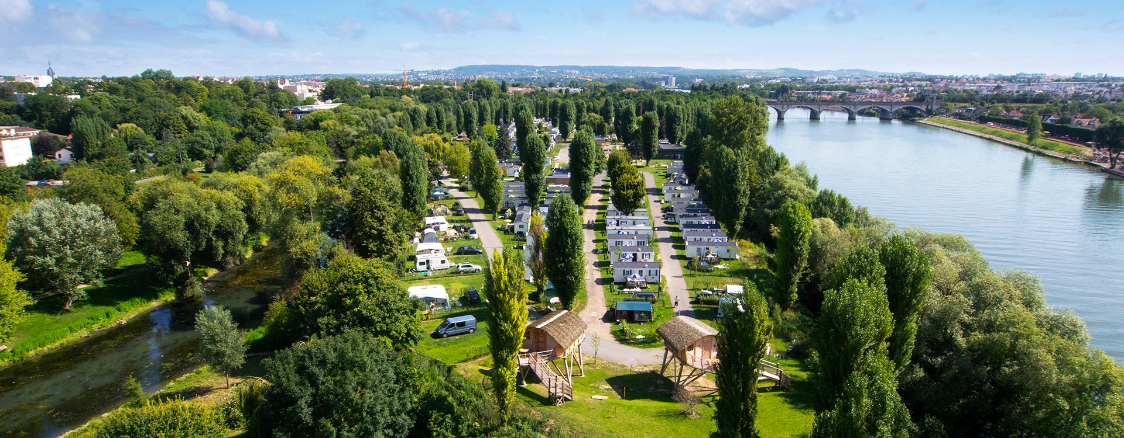

Paris West Tennis Academy is situated on a fantastic location in Maisons-Laffitte, Paris

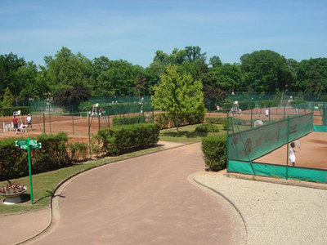

Tennis complex with 16 red clay courts plus much, much more….

By continuing to innovate we are proud to announce that participants of TEN-PRO – PARIS will be able to learn and take advantage of use the most advanced tennis video system of today! PLAYSIGHT

Get more from your game with PlaySight live streaming and video review. Analyze and improve like the pros.
TAKE A OPPORTUNITY AND VISIT ROLAND GARROS SITE

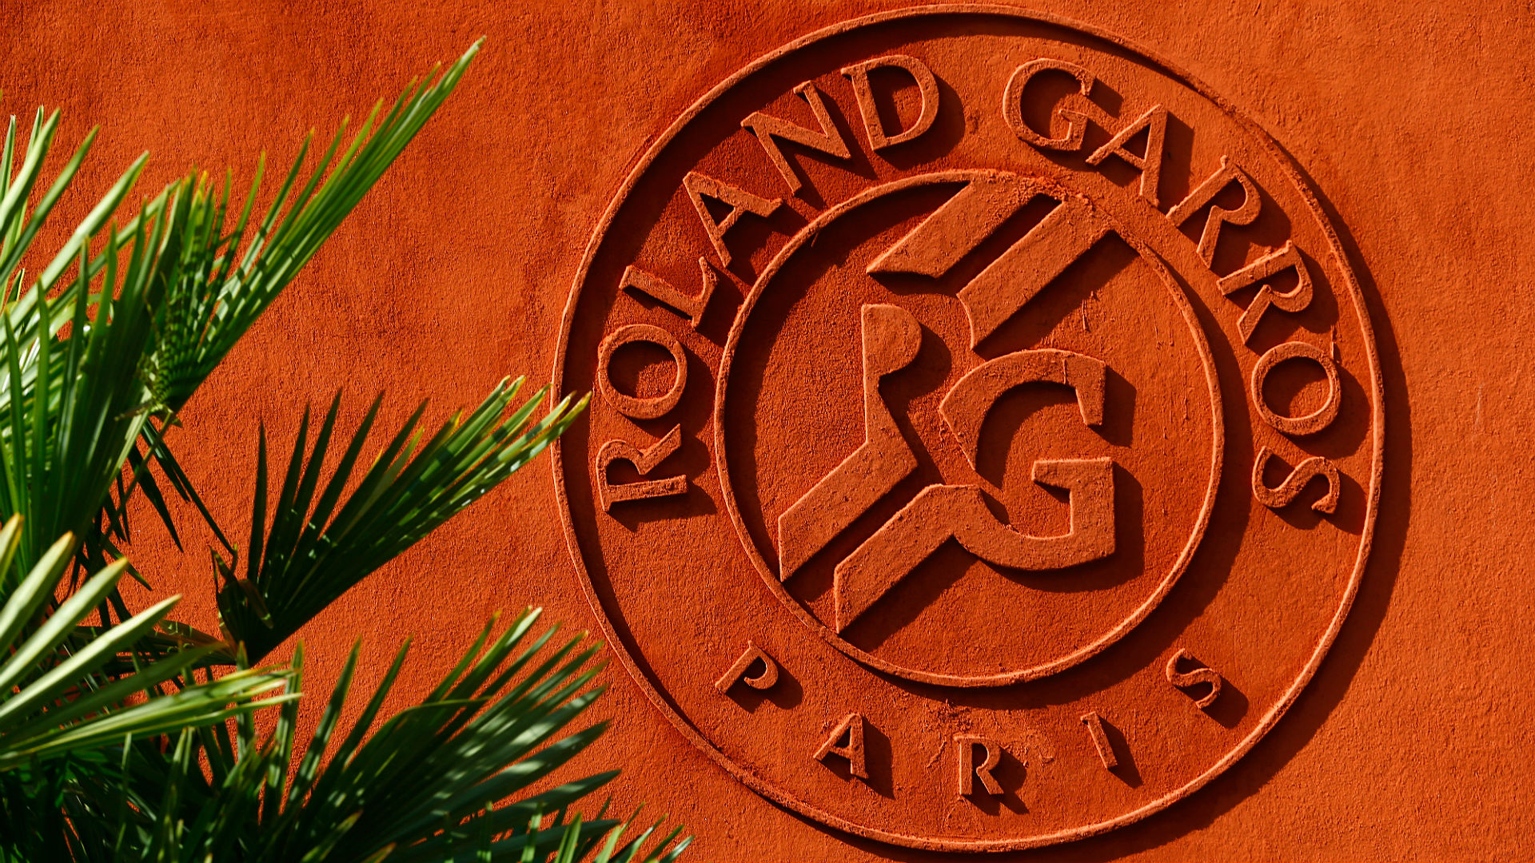

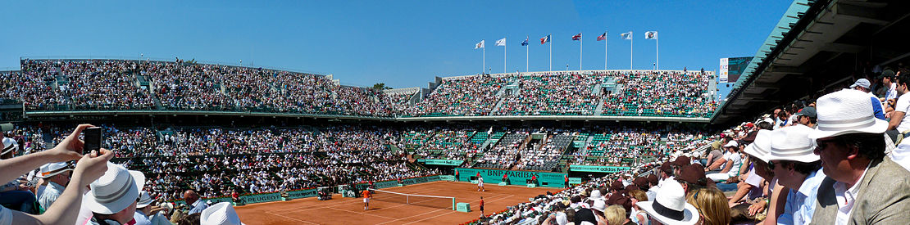

PARIS CITY

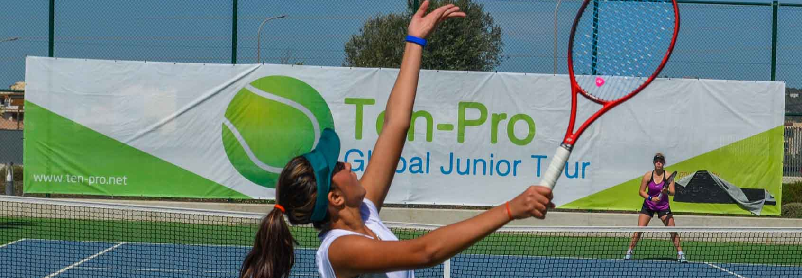

TEN-PRO & Paris West Tennis Academy invite you to participate at

International tennis tournament for worldwide highly talented boys and girls, in categories U10 up to U15, Six separate age category competitions at the same time, from born 2005 up to 2012.

TOURNAMENTS INFORMATION!

This outdoor tournament will be held at Paris West Tennis Academy
Address: 6 Avenue Desaix, 78600 Maisons-Laffitte, Paris, France.

WE GUARANTEE EVERY PLAYER 4 OR 8 MATCHES! *see regulations

NOTE: Registration for participating in two categories is possible! in that case we guaranteed 8 matches! (in your own category plus an one EXTRA older age category).

TOURNAMENTS RESULTS ARE COUNTED BY UTR (Universal Tennis Rating)
https://www.myutr.com/

TEN-PRO RANKING SYSTEM! “SCORE YOUR POINTS AND EARN YOUR REWARD”
http://www.ten-pro.nl/ranking-system/

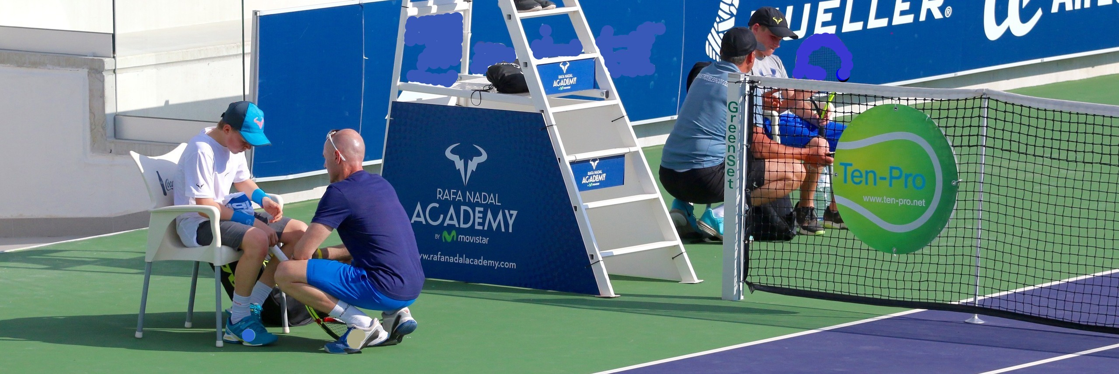

COACHING ON-COURT ALLOWED!
During the tournament parents and coaches will also have a chance to learn and experienced tennis talents development.

The competition regulations, tennis camp, schedules and other useful information about the tournament can be found on our website www.ten-pro.net , we will provide additional information about the tennis accommodation, hotels and other local facilities. Young top talents in tennis will be able to compete and learn from each other.

There are great prizes to win, such as:

- Tournament T- shirt for each participant!
- PWTA trophies and package for the winners (1,2 and 3rd place)
- TEN-PRO package for the winners.
- TEN-PRO Global Junior Tour certificate for all participants.
- Furthermore it will create an outstanding support base in obtaining the perfect sponsor agreement!
- And other prizes from our proud sponsors and partners.

We kindly ask you to send this letter with invitation to your best tennis players, born from 2005 up to and 2012. We hope to receive as many applications, from talented players, as possible because together we can make this a fantastic and worthwhile tournament!
To participate, please fill in the enclosed form and return it by e-mail to proglobus@live.nl f.a.o. Goran Novakovic. The closing date for registration is fixed on August 08th 2020 at 14.00. Providing the maximum number of players hasn’t reached yet at that time!

For more information we refer you to the following site: www.ten-pro.net

With your participation we will make this a fantastic event!

With kind regards,

Goran Novakovic Tournament Director

TEN-PRO Global Junior Tour / Mob.: +31 (6) 22 11 88 57 / Website: www.ten-pro.net / FB: Ten-Pro Global Junior Tour / Insta: Ten-Pro Global Junior Tour / Twitter: @TenProGlobaljr

