U10 - U11 - U12 – U13 – U14 – U15 Patrick Mouratoglou

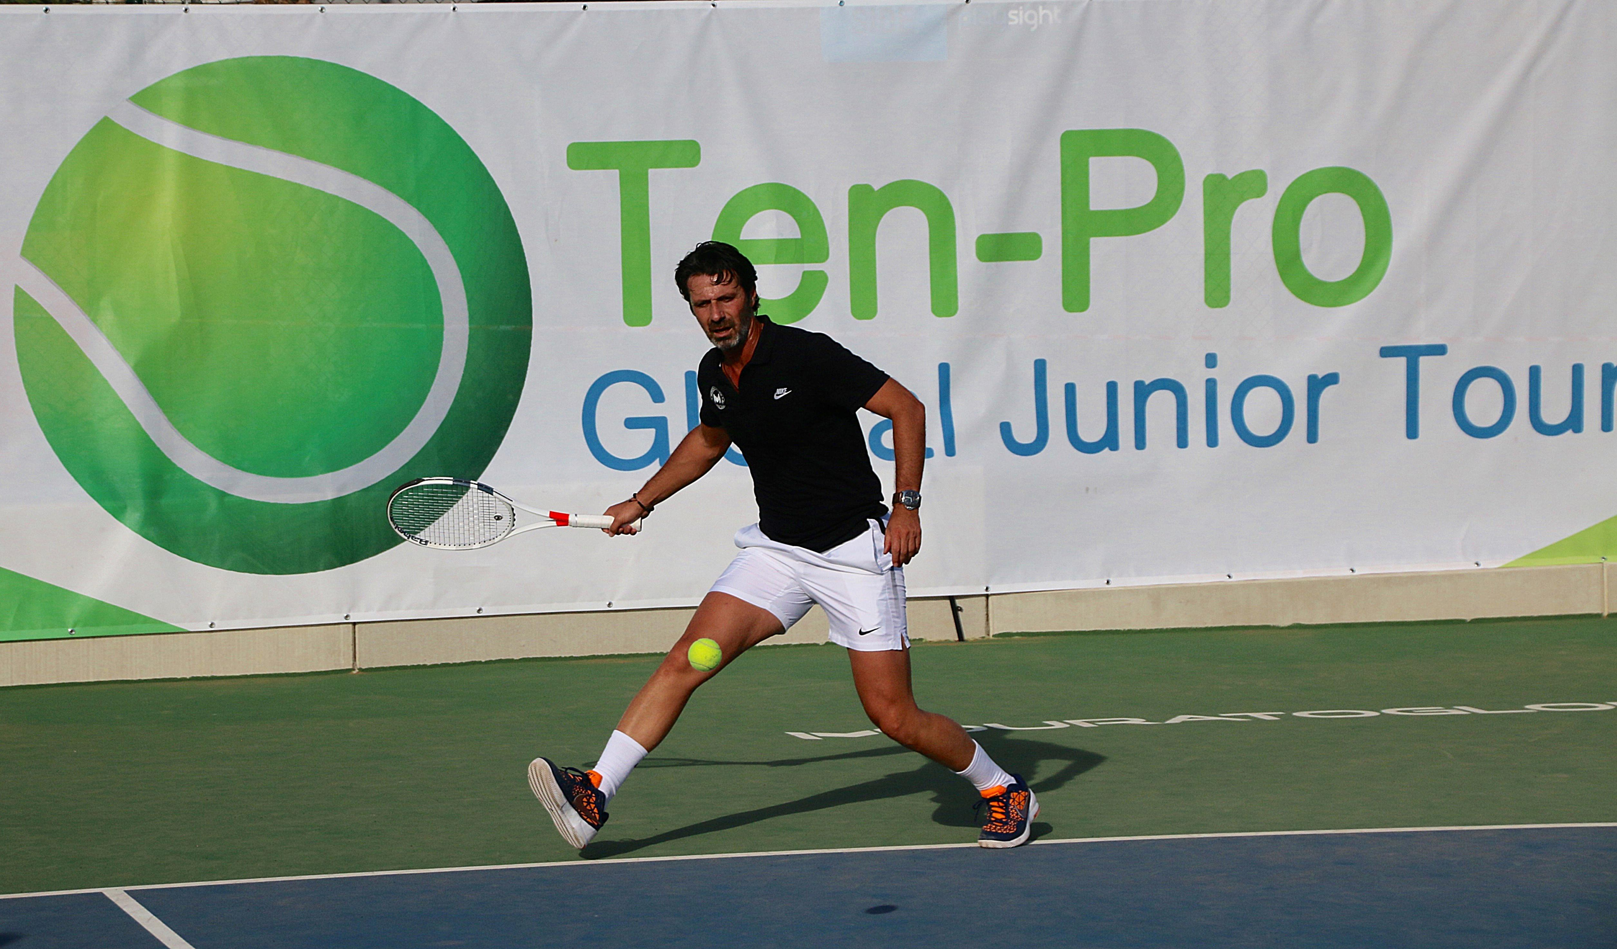

Special invitation to participate on the MOURATOGLOU by TEN-PRO Global Junior Tour 2020

IMPORTANT INFORMATION

Sunday 3th to Saturday 9th May 2020

4 or 8 MATCHES GUARANTEED FOR EVERY PARTICIPANT! * See regulations

Organizers:
www.ten-pro.net

Contact & Registration:
proglobus@live.nl
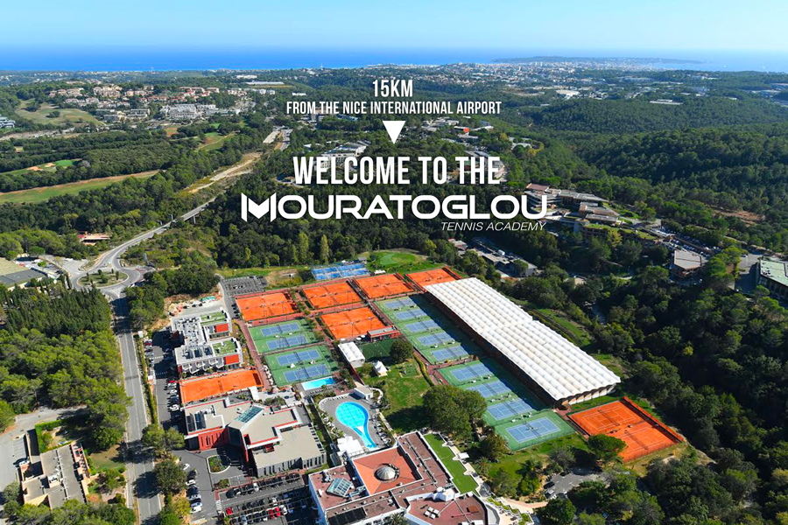

Mouratouglou Tennis Academy is situated on a fantastic location in the heart of the French Riviera, with new “State of the art” tennis complex and with 34 tennis courts can be with proud called one of the leading tennis academy in World!

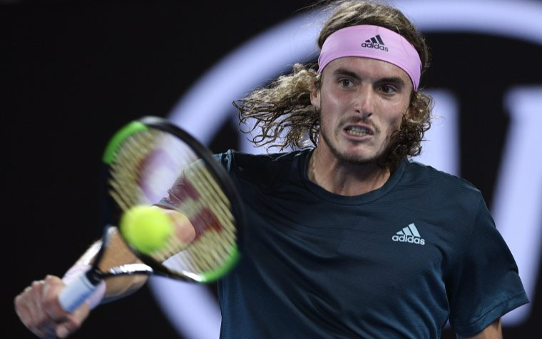

Many world-famous tennis players have been grown or have undergone through MTA,
some of them are: Stefanos Tsitsipas (Foto) Marcos Baghdatis, Grigor Dimitrov, Jérémy Chardy, Anastasia Pavlyuchenkova, Laura Robson … and many others, Of course last but not the last in a series of these names is Serena Williams world's No.1 ,23 Grand Slam titles in singles (won each Grand Slam tournament at least three times!) and thirteen GS titles in the women’s doubles!
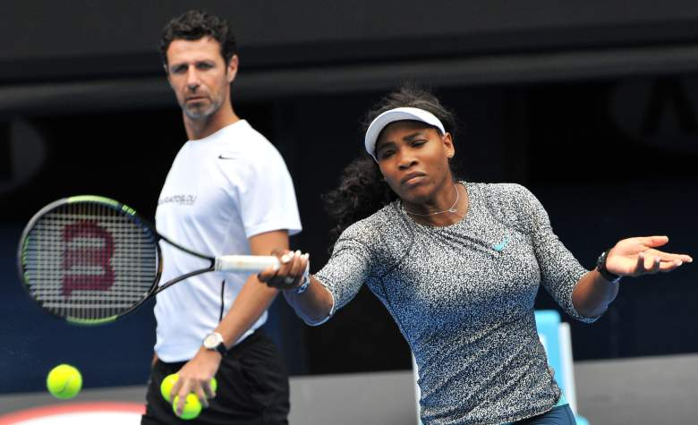

TEN-PRO & MOURATOGLOU TENNIS ACADEMY invite you to participate at:

An international tennis tournament for worldwide highly talented boys and girls, in categories U10 up to U15, Six separate age category competitions at the same time, from born 2005 up to 2012.

TOURNAMENTS INFORMATION!

This outdoor tournament will be held at Mouratoglou Tennis Academy
Address: 3550 Route des Dolines 06410 Biot , France

WE GUARANTEE EVERY PLAYER 4 OR 8 MATCHES! *see regulations

NOTE: Registration for participating in two categories is possible! in that case we guaranteed 8 matches! (in your own category plus an one EXTRA older age category).This request should be send to proglobus@live.nl for the attention of Goran Novakovic.

TEN-PRO & PlaySight

Get more from your game with PlaySight live streaming and video review. Analyze and improve like the pros.
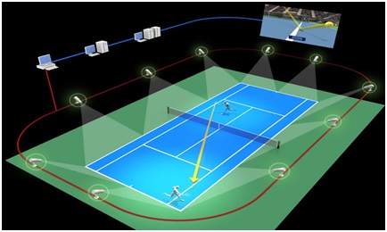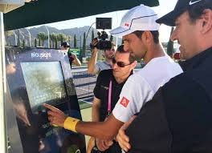
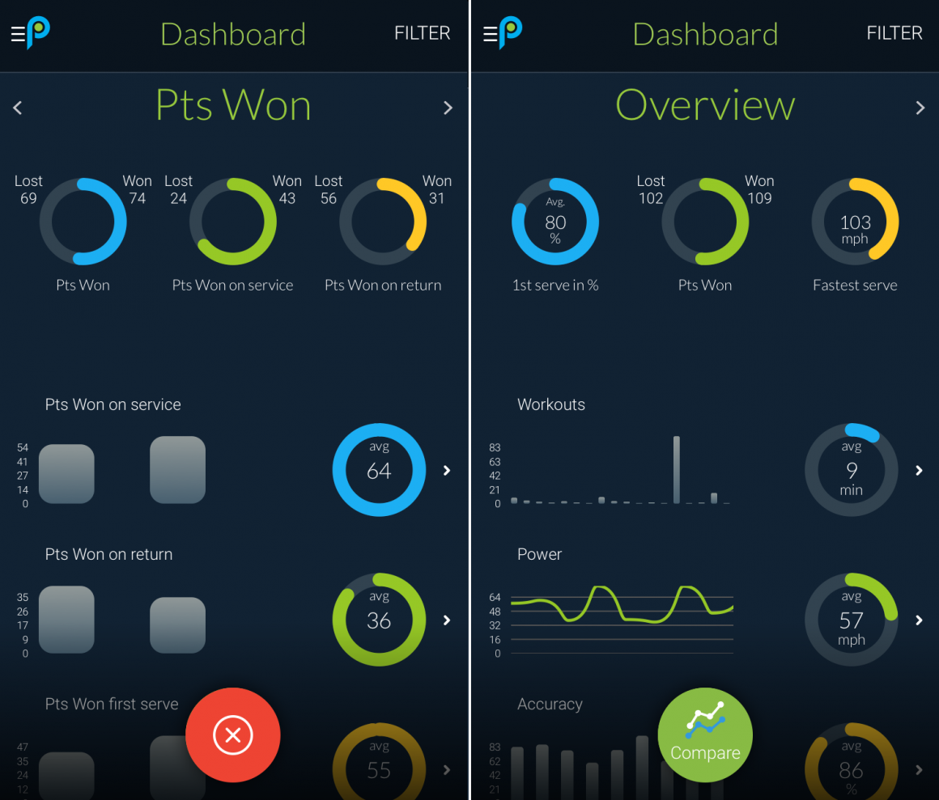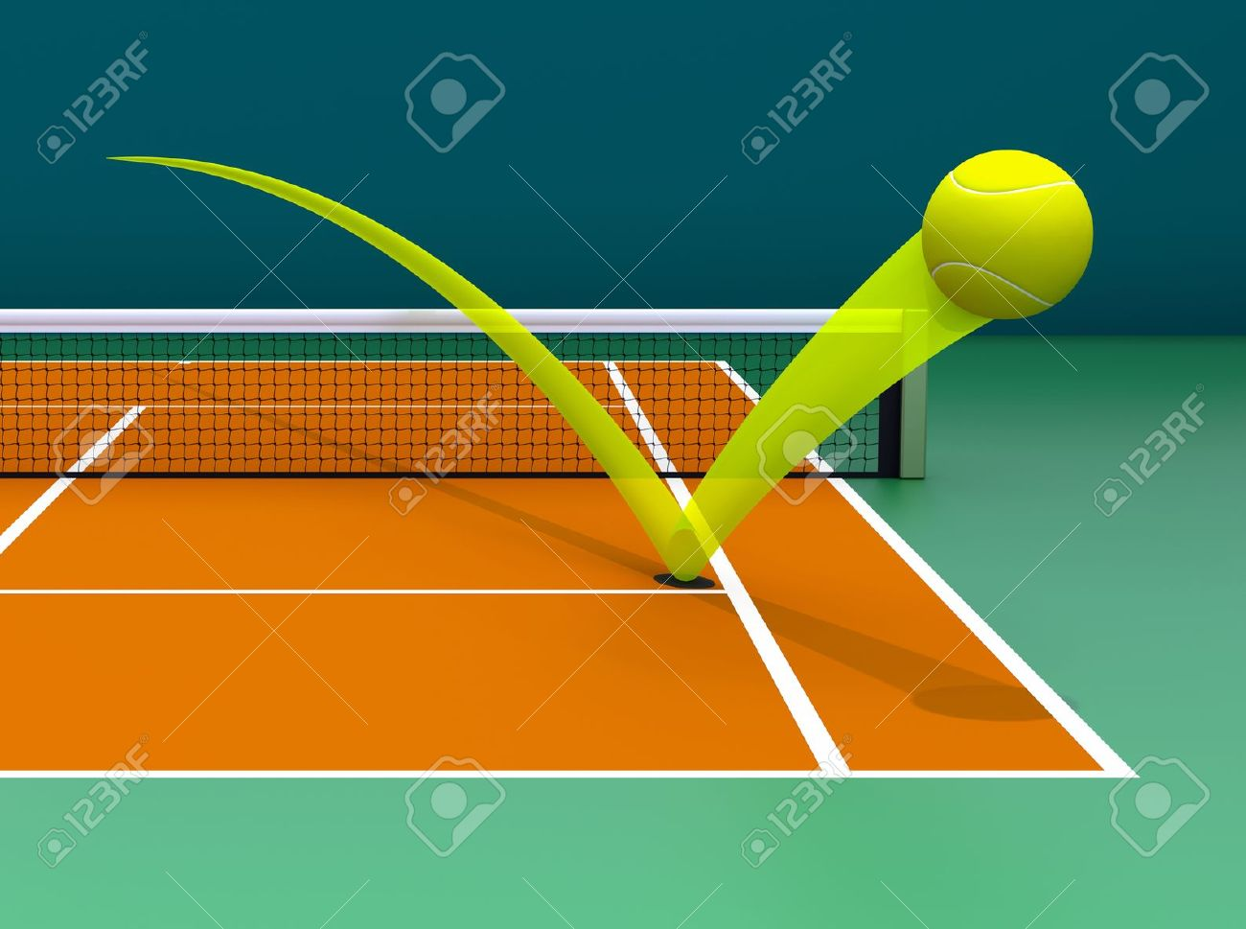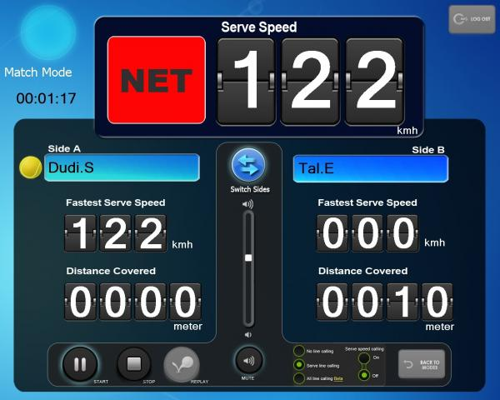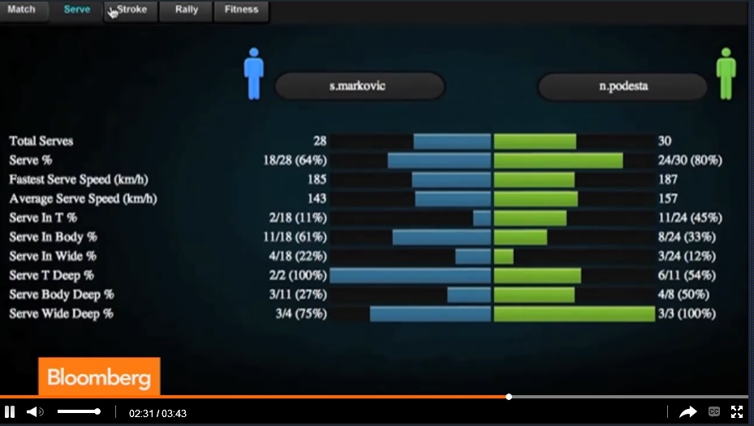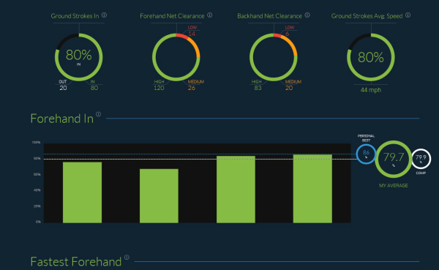

COACHING ON-COURT ALLOWED!

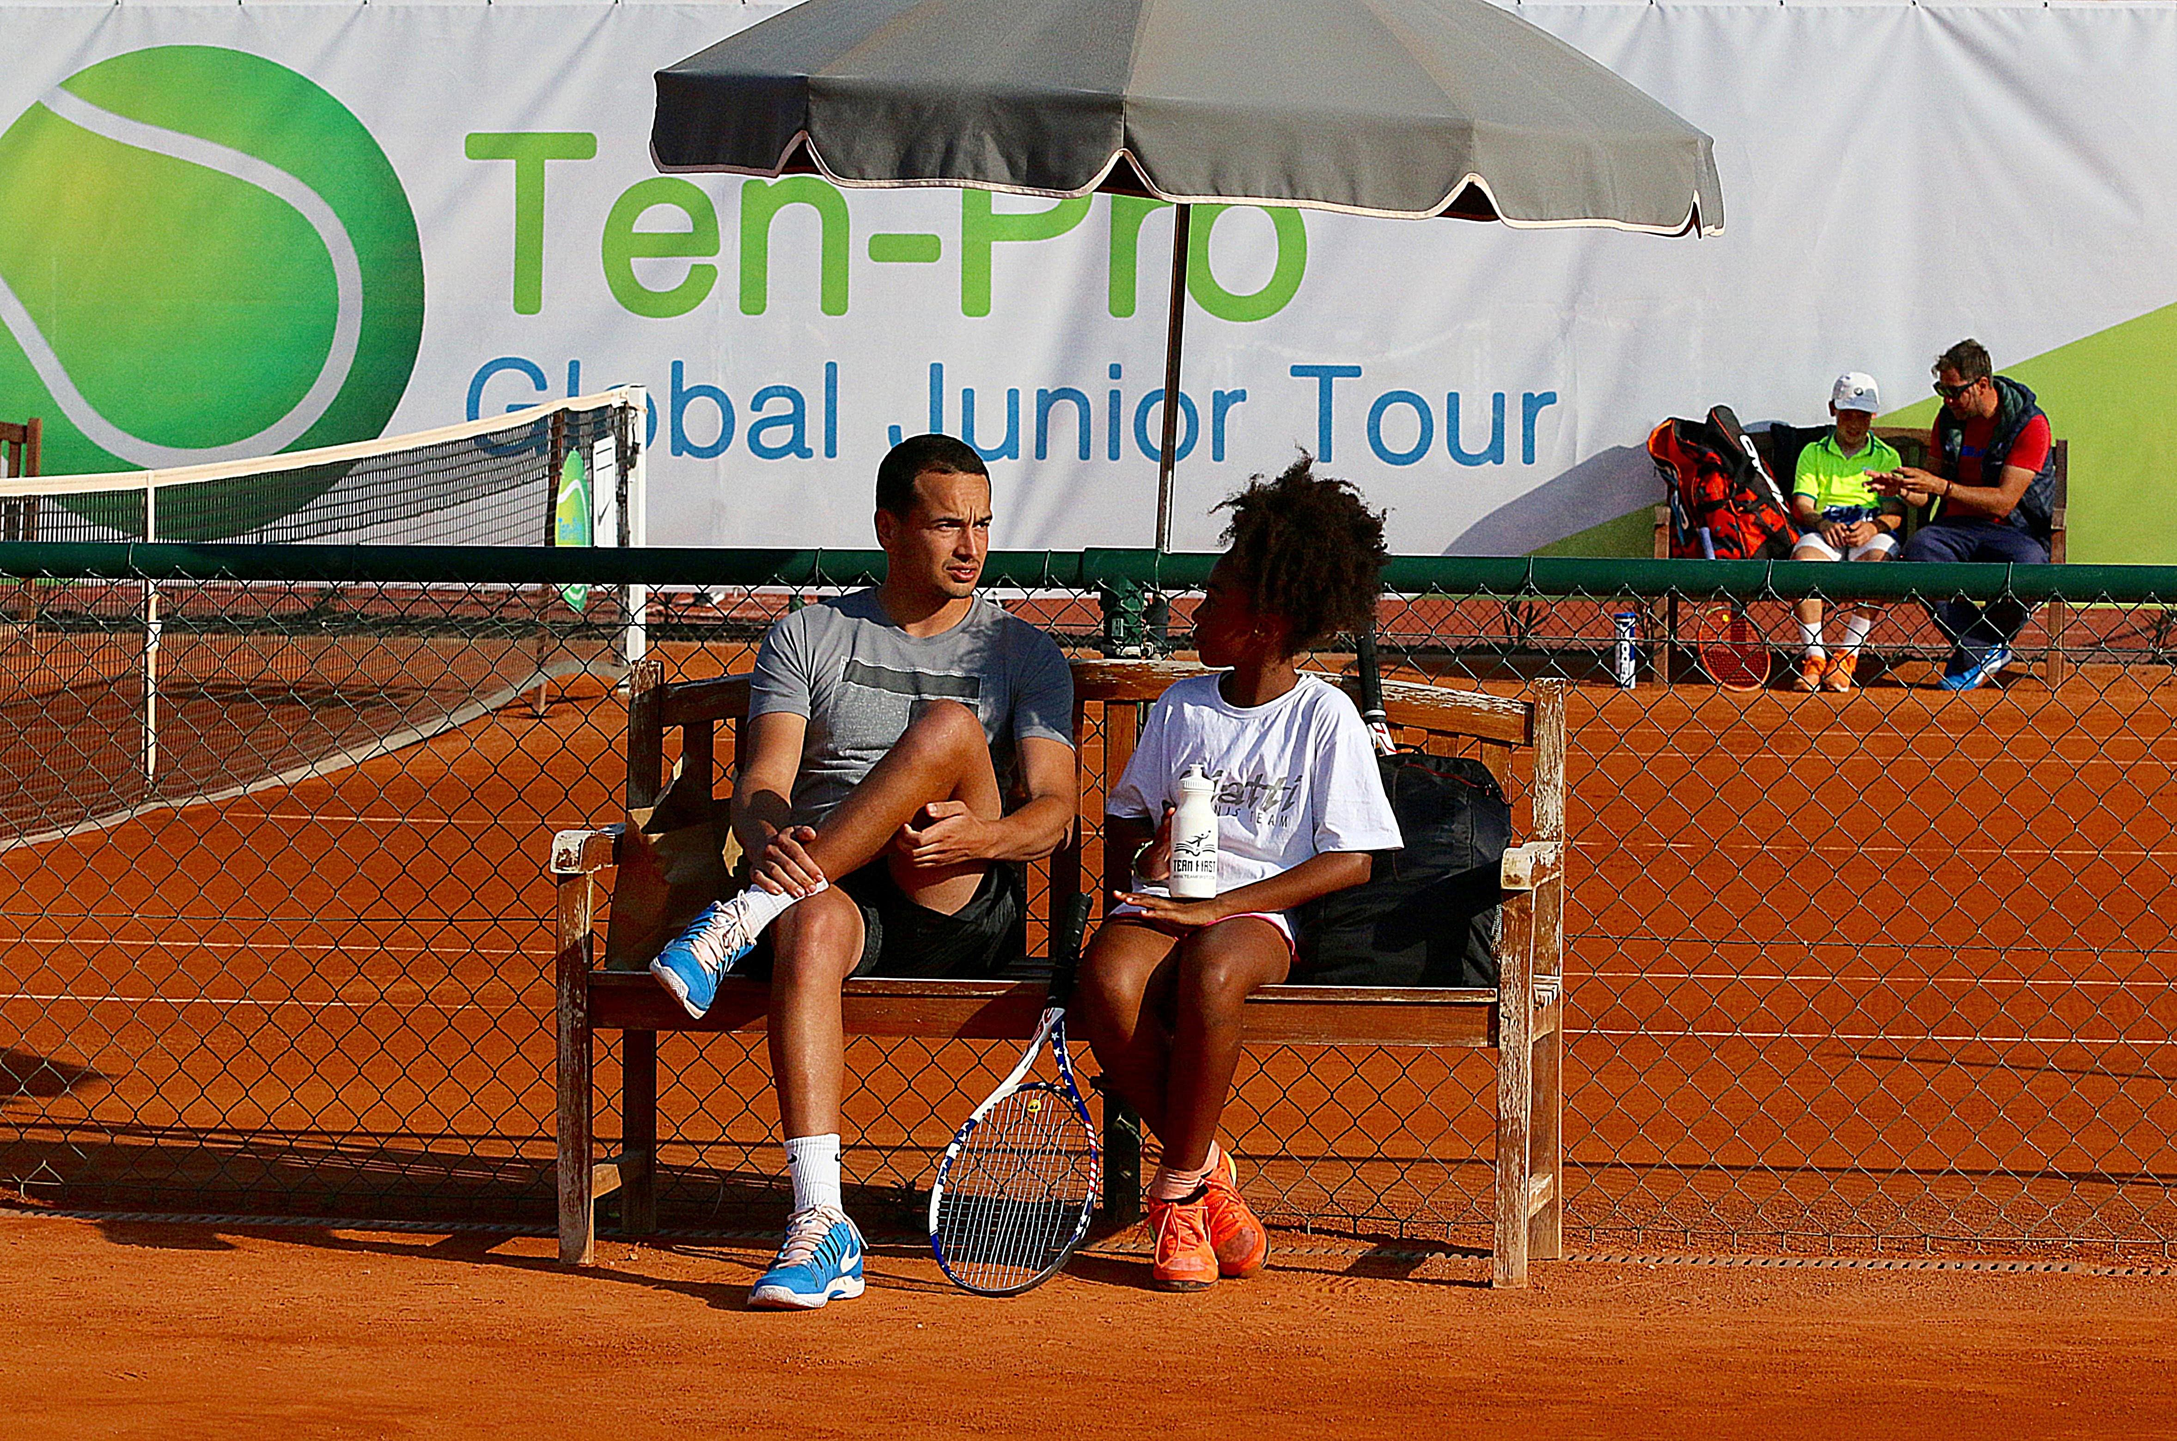

TOURNAMENTS RESULTS ARE COUNTED BY UTR (Universal Tennis Rating)
https://www.myutr.com/

TEN-PRO RANKING SYSTEM! “SCORE YOUR POINTS AND EARN YOUR REWARD”
http://www.ten-pro.nl/ranking-system/

Every player on our tour can score points for the results they achieve in our tournaments. At the end of the year this will result in a TEN-PRO ranking. With your ranking you can earn your reward such as a trainingsweek at Academy, a sponsor contract, tennis materials, wild cards and many other prizes from our proud sponsors and partners.

TRAINING CAMP

In order to have your players prepared for the upcoming tournament players can choose to join the camp sessions, book individual sessions with Mouratoglou. With these options we will have the majority of your needs covered.

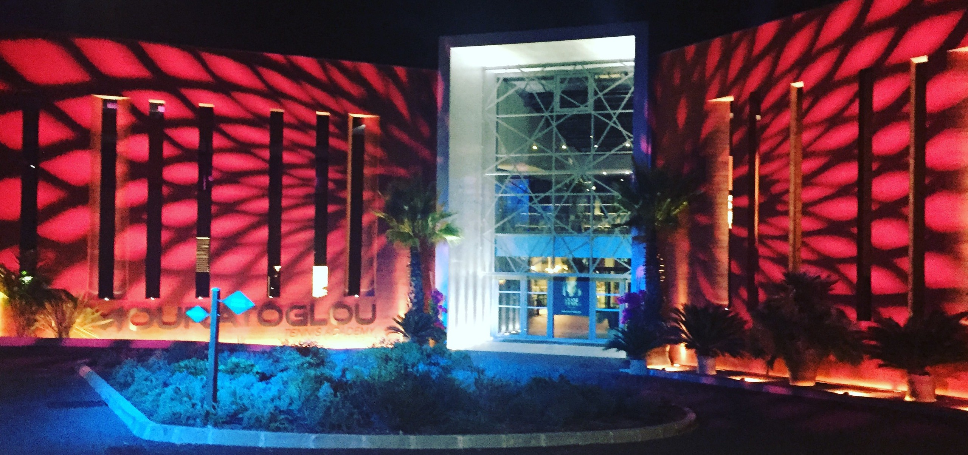

The competition regulations, tennis camp, schedules and other useful information about the tournament can be found on our website www.ten-pro.net , we will provide additional information about the tennis accommodation, hotels and other local facilities. Young top talents in tennis will be able to compete and learn from each other.

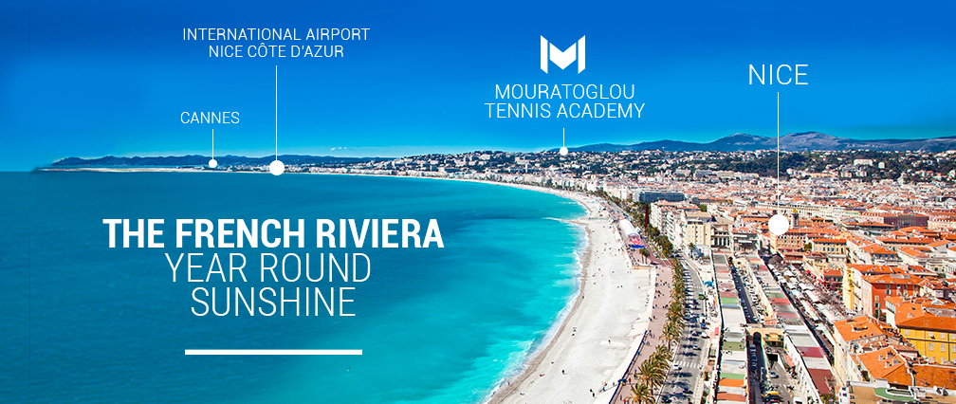

During the tournament parents and coaches will also have a chance to learn and experience tennis talents development and enjoy their stay at the beautiful French Riviera!

There are great prizes to win, such as:

- TEN-PRO T-shirt for each participant!
- MTA trophies and package for the winners (1,2 and 3rd place)
- TEN-PRO package for the winners.
- TEN-PRO Global Junior Tour certificate for all participants.
- Possibility of Wild Card for other tournaments
- Furthermore it will create an outstanding support base in obtaining the perfect sponsor agreement!
- And other prizes from our proud sponsors and partners.

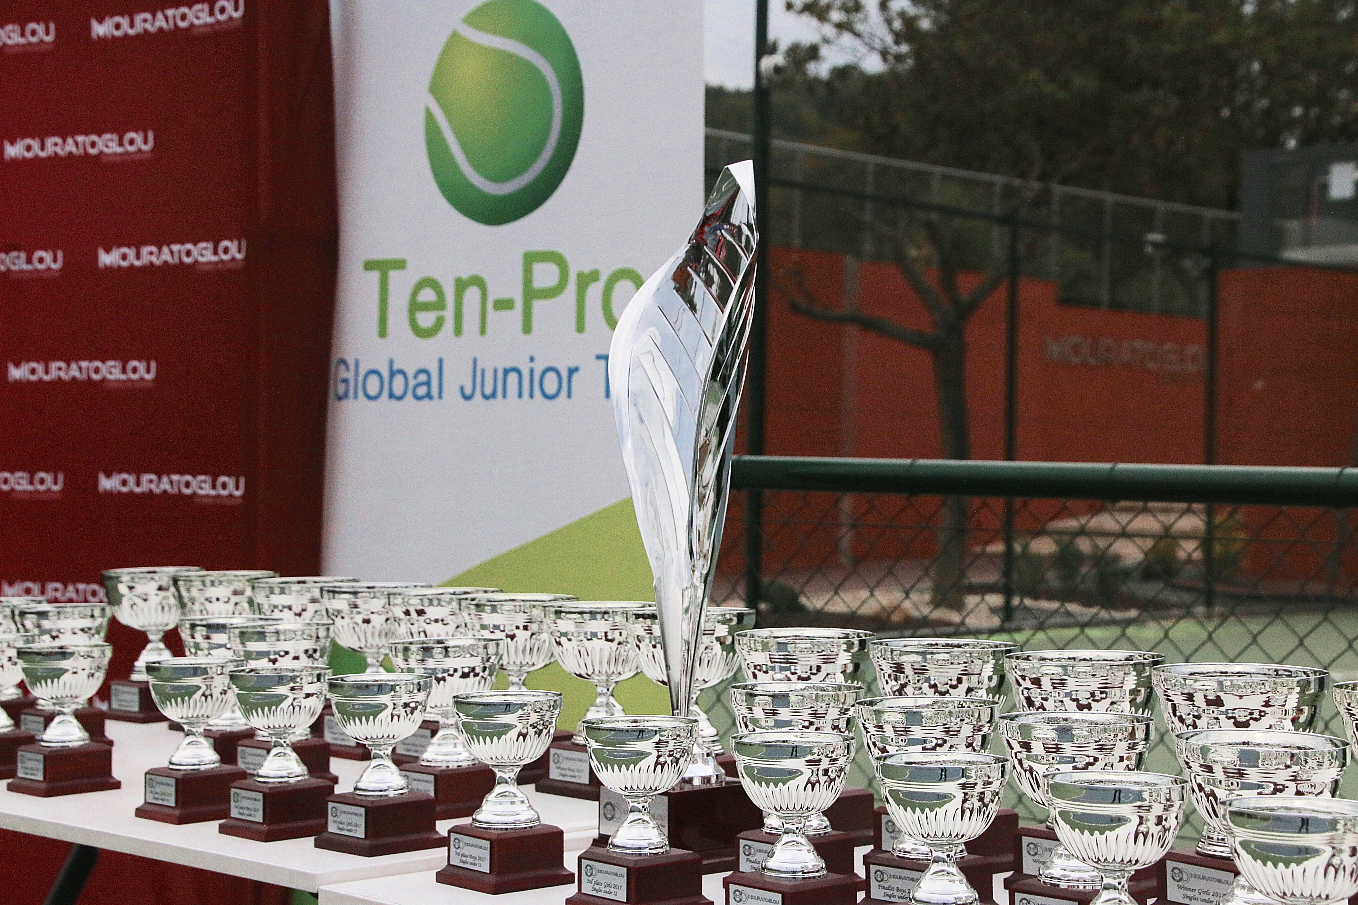

We kindly ask you to send this letter with invitation to your best tennis players, born from 2005 up to and 2012. We hope to receive as many applications, from talented players, as possible because together we can make this a fantastic and worthwhile tournament!

To participate, please fill in the enclosed form and return it by e-mail to proglobus@live.nl f.a.o. Goran Novakovic. The closing date for registration is fixed on April 24th 2020 at 14.00.

For more information we refer you to the following site: www.ten-pro.net

With your participation we will make this a fantastic event!

With kind regards,

Goran Novakovic Tournament Director

In partnership with

TEN-PRO Global Junior Tour / Mob.: +31 (6) 22 11 88 57 / Website: www.ten-pro.net / FB: Ten-Pro Global Junior Tour / Insta: Ten-Pro Global Junior Tour / Twitter: @TenProGlobaljr

