KIM CLIJSTERS by TEN-PRO Global Junior Tour
U10 - U11 - U12 – U13 – U14 – U15

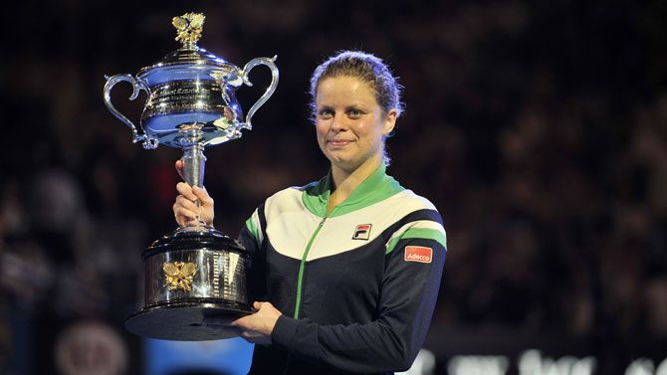

Special invitation to participate on the KIM CLIJSTERS by TEN-PRO Global Junior Tour

IMPORTANT INFORMATION

Tuesday 23st to Sunday 28th 2020

4 or 8 MATCHES GUARANTEED FOR EVERY PARTICIPANT! * See regulations

Organizers:
www.ten-pro.net & www.kimclijstersacademy.be

Contact & Registration:
proglobus@live.nl
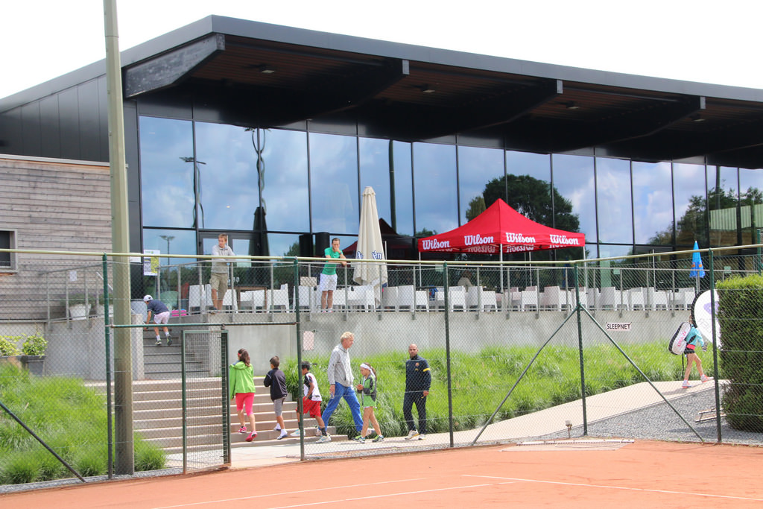

KIM CLIJSTERS Tennis Academy is situated on a fantastic location in city of Bree, with wonderful tennis complex (outdoor and indoor), Fitness Centre plus much, much more…

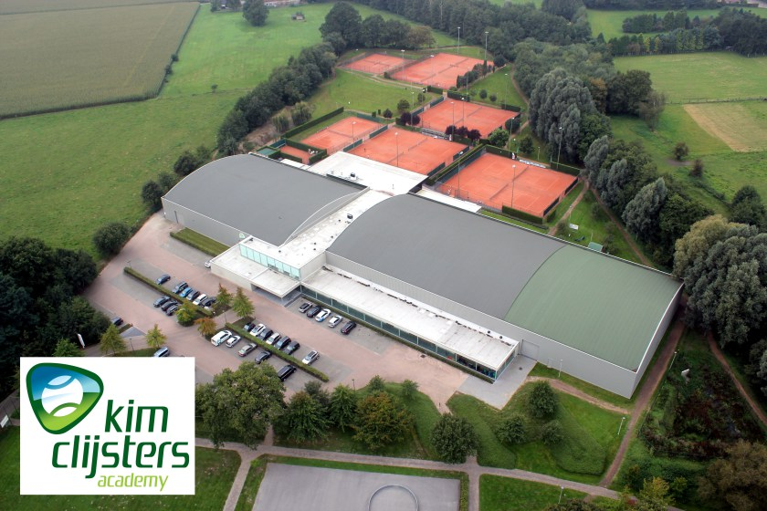

KCA opens its doors to young players to train with the method that has led Kim to be number one, with guarantees of being surrounded by the best coaches and the best technical team in the tennis’ field.

TEN-PRO & KIM CLIJSTERS ACADEMY invite you to participate at:

An international tennis tournament for worldwide highly talented boys and girls, in categories U10 up to U15, Six separate age category competitions at the same time, from born 2005 up to 2012.

TOURNAMENTS INFORMATION!

This outdoor tournament will be held at Kim Clijsters Tennis Academy
Address: Watertorenstraat 16A Bree, Belgium

WE GUARANTEE EVERY PLAYER 4 OR 8 MATCHES! *see regulations

NOTE: Registration for participating in two categories is possible! in that case we guaranteed 8 matches! (in your own category plus an one EXTRA older age category).This request should be send to proglobus@live.nl for the attention of Goran Novakovic.

COACHING ON-COURT ALLOWED!

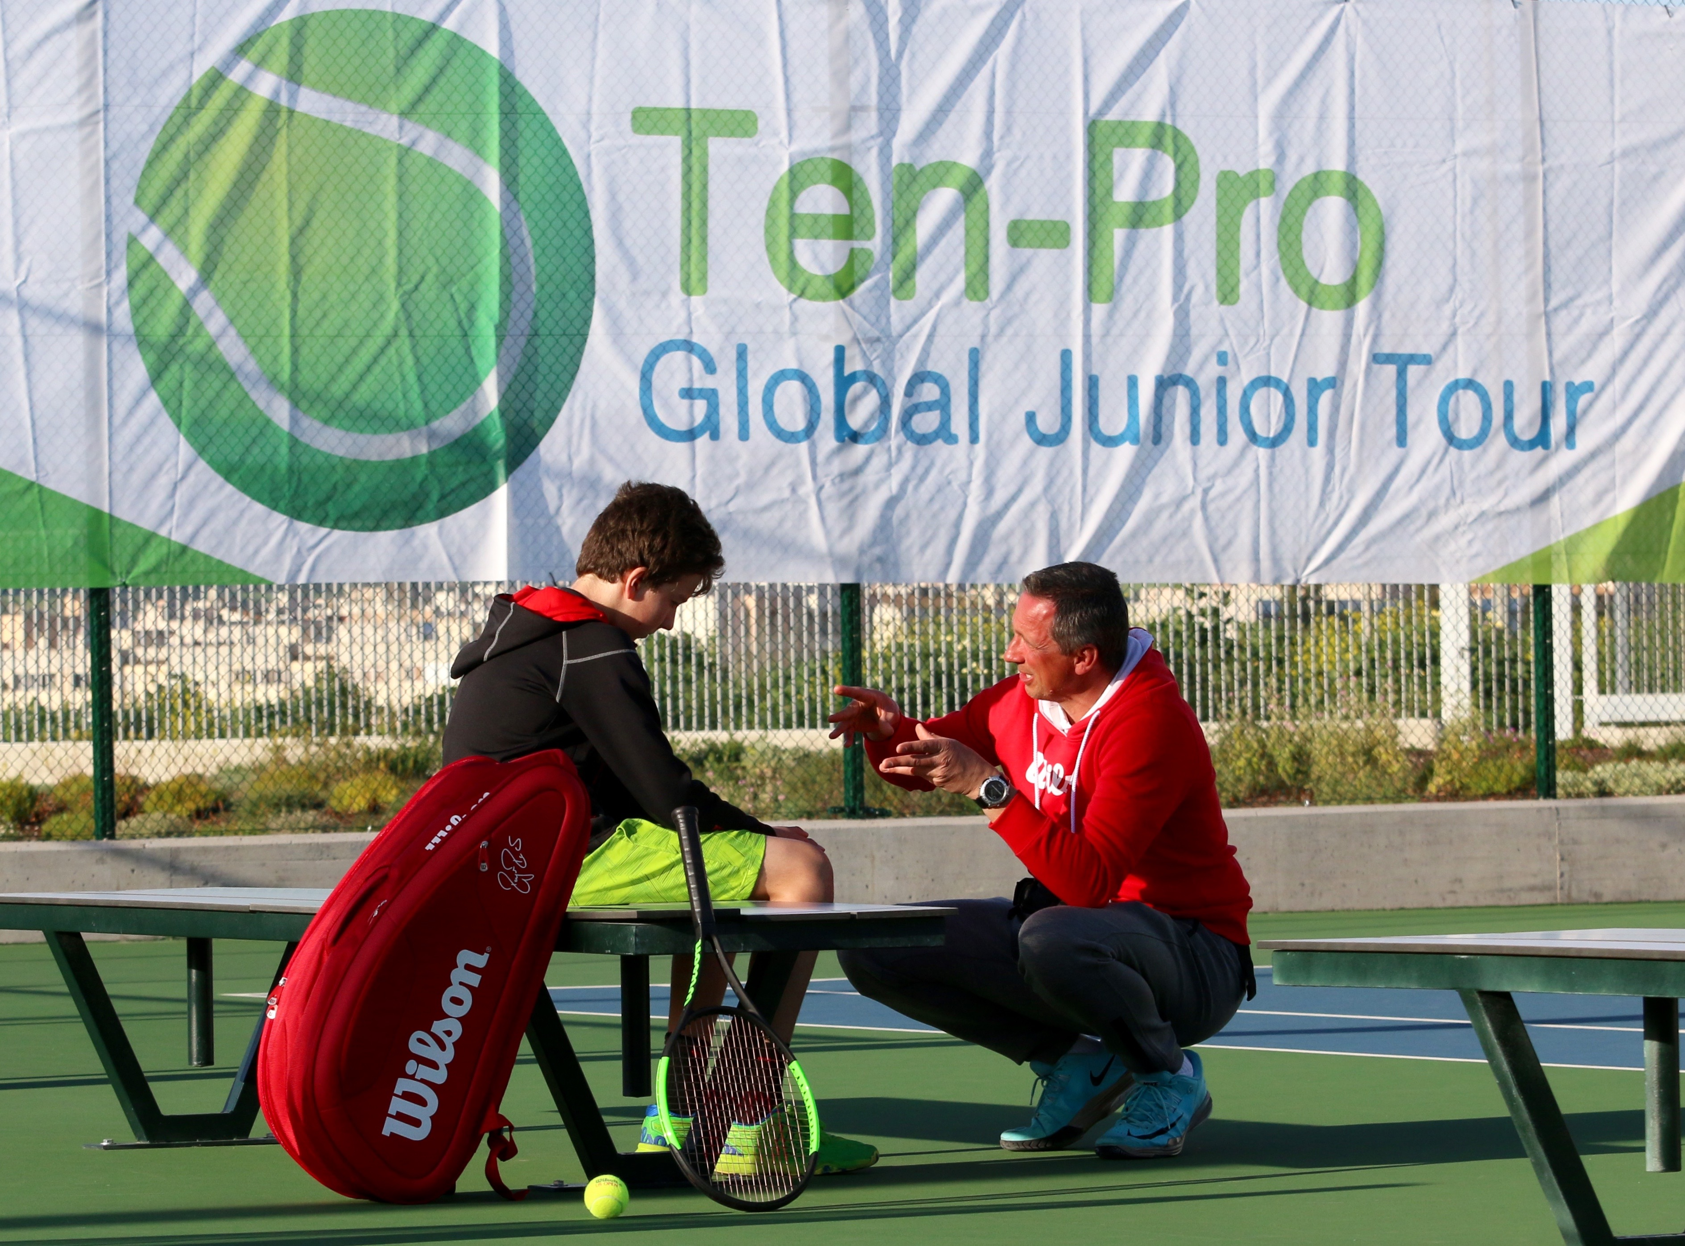
TOURNAMENTS RESULTS ARE COUNTED BY UTR (Universal Tennis Rating)
https://www.myutr.com/

TEN-PRO RANKING SYSTEM!
“SCORE YOUR POINTS AND EARN YOUR REWARD”
http://www.ten-pro.nl/ranking-system/

Every player on our tour can score points for the results they achieve in our tournaments. At the end of the year this will result in a TEN-PRO ranking. With your ranking you can earn your reward such as a trainingsweek at Kim Clisters Academy, a sponsor contract, tennis materials, wild cards and many other prizes from our proud sponsors and partners.

TRAINING CAMP

Practice at KCA from Saturday 20th up to and including Monday 22th of June 2020.

In order to have your players prepared for the upcoming tournament we have arranged a special training package where everyone can choose the options which suits their needs. Players can choose to join the camp sessions, book individual sessions with Kim Clijsters Academy coaches or rent a court to play with their own coaches. With these three options we will have the majority of your needs covered.

TEN-PRO & PlaySight

Get more from your game with PlaySight live streaming and video review. Analyze and improve like the pros.

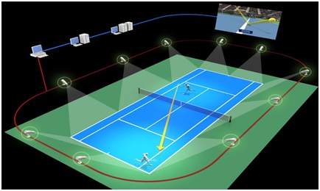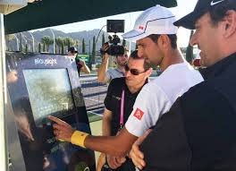

KIM CLIJSTERS ACADEMY & Hawkeye
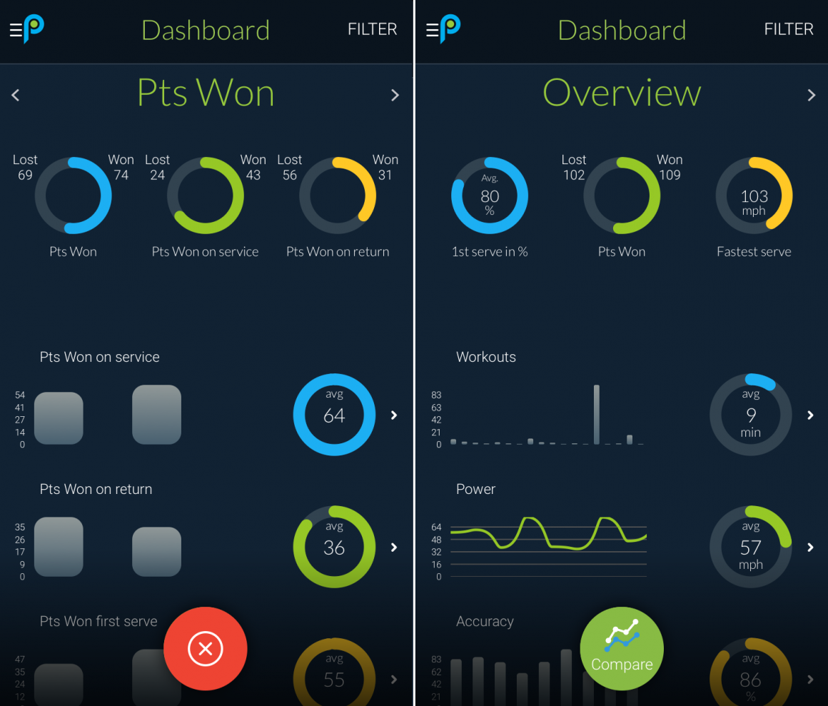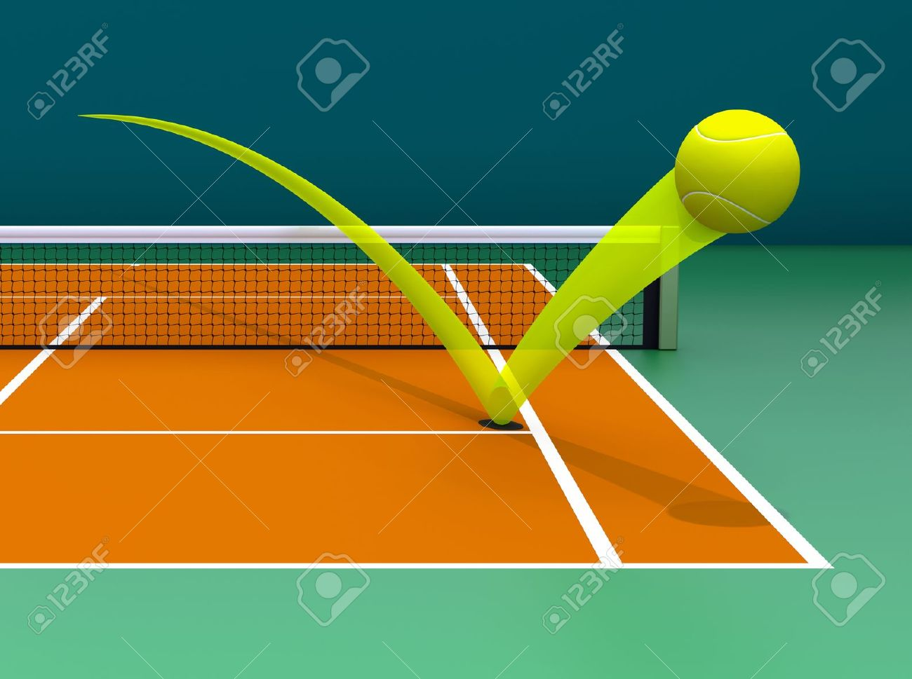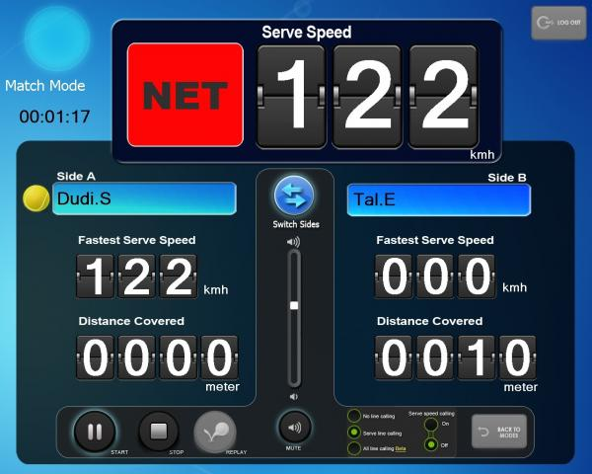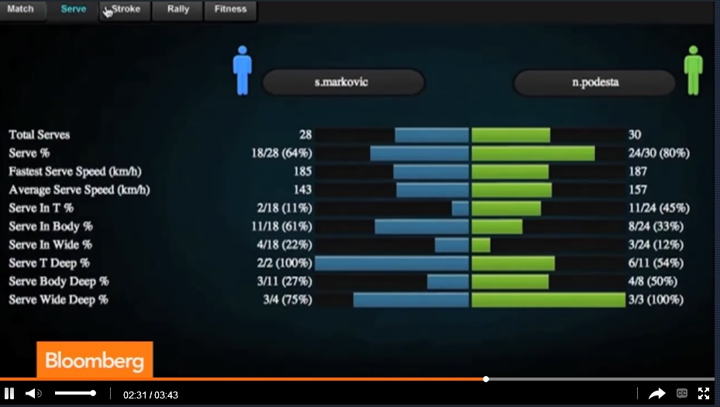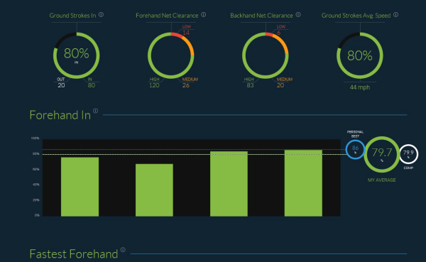

The competition regulations, tennis camp, schedules and other useful information about the tournament can be found on our website www.ten-pro.net , we will provide additional information about the tennis accommodation, hotels and other local facilities. Young top talents in tennis will be able to compete and learn from each other.

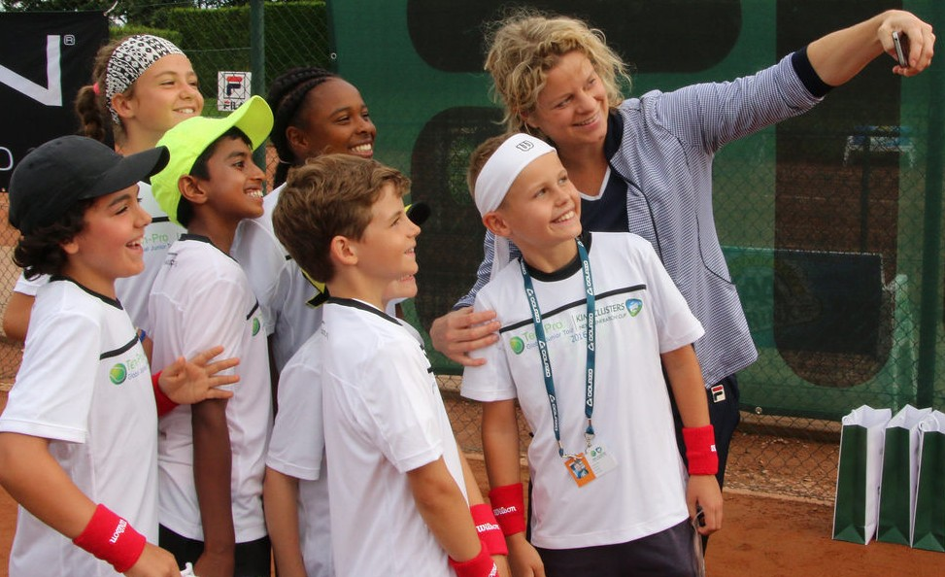

IT’S ALL ABOUT DEVELOPMENT

During the tournament parents and coaches will also have a chance to learn and experience tennis talents development and enjoy their stay at the beautiful part of Belgium, Limburg!

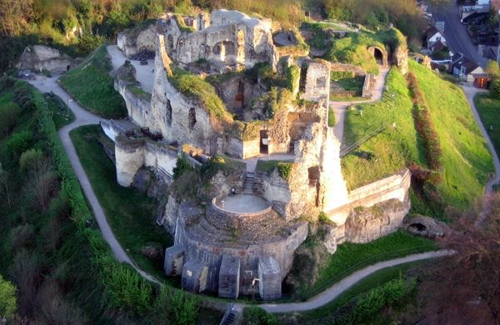
There are great prizes to win, such as:

- T- shirt for each participant!
- KCA trophies and package for the winners (1,2 and 3rd place)
- TEN-PRO package for the winners.
- TEN-PRO Global Junior Tour certificate for all participants.
- Possibility of Wild Card for many other tournaments
- Furthermore it will create an outstanding support base in obtaining the perfect sponsor agreement!
- And other prizes from our proud sponsors and partners.

We kindly ask you to send this letter with invitation to your best tennis players, born from 2005 up to and 2012. We hope to receive as many applications, from talented players, as possible because together we can make this a fantastic and worthwhile tournament!

To participate, please fill in the enclosed form and return it by e-mail to proglobus@live.nl f.a.o. Goran Novakovic. The closing date for registration is fixed on June 15th 2020 at 14.00.
Providing the maximum number of players hasn’t reached yet at that time!

For more information we refer you to the following site: www.ten-pro.net

With your participation we will make this a fantastic event!

With kind regards,

Goran Novakovic Tournament Director

In partnership with
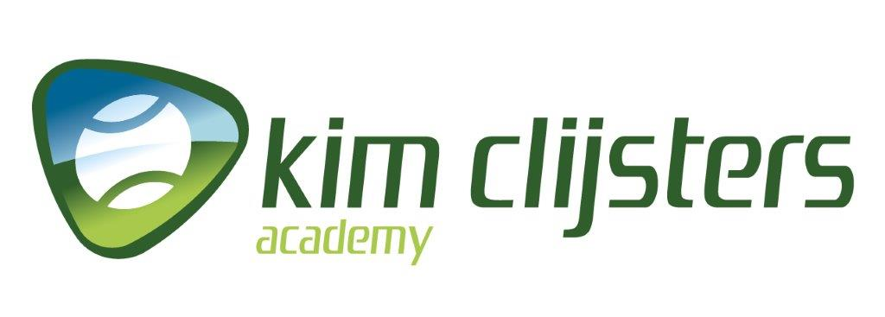
TEN-PRO Global Junior Tour / Mob.: +31 (6) 22 11 88 57 / Website: www.ten-pro.net / FB: Ten-Pro Global Junior Tour / Insta: Ten-Pro Global Junior Tour / Twitter: @TenProGlobaljr

