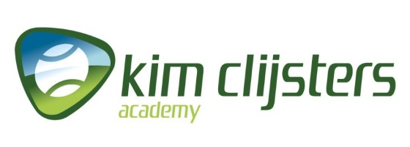

REGISTRATION FORM: KIM CLIJSTERS by TEN-PRO, 23 - 28 June 2020

Name of player :
Boy/Girl :
Date of Birth :

Representing the country :

NOTE: Registration for participating in two categories is possible in that case we guaranteed 8 matches! (in your own category plus one EXTRA older age category) * See regulations

Please indicate : Play in one or in two category ………….

Tel. Number :
Mobile nr. :

E-mail (Parents):

Name of tennis club :
E-mail of tennis club :
Name of your coach :
E-mail of your coach :

Favorite player:

You play with (racket) :

Training hours weekly :
Private training :
Training in group :
Physical training :
Mental training :

Current ranking my age :
Main results :
Your greatest wish :
Certificate of health :

By sending this registration form we declare that we have read and accept all the terms and conditions of TEN-PRO Global Junior Tour unconditionally and also that our son/daughter/player ............................................... is in perfect health and has the permission of his/her parents to take part in this tournament. We also agree that Ten-Pro have permission to make free use of all photos and films of our son/daughter/player (For Social Media of TEN-PRO or by partnership website).

TO COMPLETE THIS APLLICATION YOU ARE REQUIRED TO ENCLOSE A COPY OF YOUR ID OR PASSPORT!

To participate, please fill in the enclosed form and return it by e-mail to proglobus@live.nl f.a.o. Goran Novakovic

TEN-PRO Global Junior Tour / Mob.: +31 (6) 22 11 88 57 / Website: www.ten-pro.net / FB: Ten-Pro Global Junior Tour / Insta: Ten-Pro Global Junio Tour / Twitter: @TenProGlobaljr

