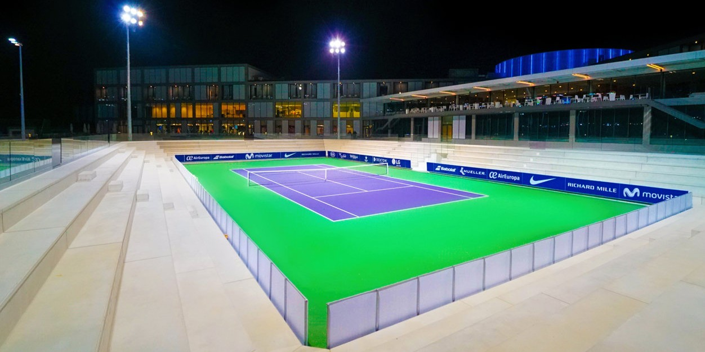

Participation fee

Payment & final participation on TEN-PRO at RAFA NADAL ACADEMY by movistar 2-8 December 2019

At the moment an individual player has received via e-mail a confirmation for playing this tournament, a participation fee amounting 95,- euro (per category) is due (excluded transaction costs of the bank!) This amount has to be paid within 5 days after the confirmation mail, into the TEN-PRO bank account:

IBAN :NL 29 ABNA 0437634647
BIC CODE :ABNA NL2A
COMPANY NAME :TEN-PRO
ADDRES :VAN DEVENTERWEG 50, 6861 EX OOSTERBEEK, NETHERLANDS
NAME OF BANK :ABN-AMRO, NETHERLANDS
ADDRESS OF BANK :UTRECHTSEWEG 147, 6862 AH OOSTERBEEK, NL
NAME OF OWNER :GORAN NOVAKOVIC

Please note that the RAFA, name, date of birth and the country of player origin has to be mentioned in the payment description.

Registration in the tournament is only final upon receipt of your payment into our bank account. A definitive confirmation of participation will follow by e-mail.

TEN-PRO administration

