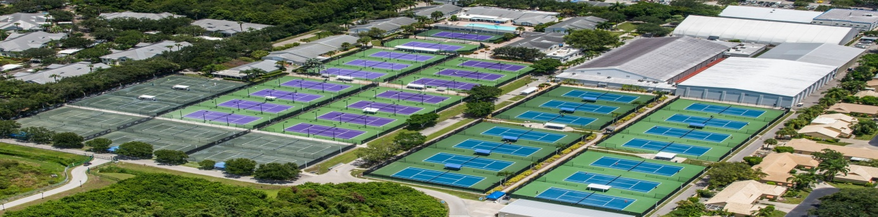

ON-COURT COACHING RULES:

On-Court coaching is allowed during the tournament (in the practice this means coach or parent as a coach is allowed to come on court during a changeover once per set, only at the end of a set, maximum of 2 minutes).

Provided the following rules and procedures are followed, a player may request that her coach go on-court during a match to provide coaching.

1. Designation Procedures

a. Both players may designate an on-court coach, one (1) coach per player is permitted on court.

b. A player can change and use a different coach during a match/tournament.

2. On-Court Coaches

a. On-court coaches are subject to Code of Conduct,including theprovisions relating to player on-court behavior.

b. On-court coaches should dress and present themselves in a professional manner. They must wear appropriate attire.Tracksuits and t-shirts will be permitted. Whether a coach is dressed professionally shall be at thesole discretion of the Supervisor and Referee and shall not beappealable. If a coach is asked to change and fails to do so, it shall result in his/her on-court coaching privileges being removed for that match.
c. If On-court coache behaved aggressively of unacceptable in any way he/she will be not be allowed to participate in on-court coaching for the remainder of the Tournament.

d. On-court coaches may converse in their chosen language.

e. On-court coaches should sit in the designated coaching seats toallow easy and quick access to the court. The coach must use theofficial court entrance to get onto the court and can under no circumstancesclimb the stands or jump over fences, which mayresult in his/her on-court coaching privileges being removed.

f. On-court coaches shall only provide verbal assistance/advice duringthe on-court coaching period and are not permitted to bringany articles (i.e., food, drinks, equipment, or medical supplies) onto
the court to provide to their player(s). Notes may be brought onto the court but may not be left with the player.

g. On-court coaches must leave the court immediately upon theSupervisor or Chair Umpire announcing “Time”.

h. On-court coaches may not provide coaching or communicate with a player outside of the court.
Coaches are subject to the normal coaching rules outside the oncourt coaching procedures and may be penalized in accordance to the Penalty Point system.

3. On-Court Coaching Requests

a. On-court coaching requests must be made to the Supervisor or Chair Umpire.

b. During a match, a player can request her coach at the following times:
i. Once per set (at the end of a set).
A set break will count as part of the set that just finished;*

c. On-court coaching can start from when the coach is called to court or when the player leaves the court, respectively.
ii. On-court coaching maximum time allowed is 120 seconds (two minute)
iii.In case of violation of time Coaches may be penalized in accordance
to the Penalty Point system. Or may result in his/her on-court coaching privileges being removed.

d. For the rest of the match verbal or gesticulated coaching during the match is not permitted and can lead to violation of the rules (PPS: violation of the rules, coaching outside On-Court coaching time).

e. If a player makes an on-court coaching request without Supervisor or Chair Umpire (her opponent) asking or taking a change of attire/toilet break, such request will count as her one (1) allowed on-court coaching request for that set, regardless of whether her opponent also
makes a request for her coach.

f. During a match, a player can only make one (1) of the following requests at the same time: (i) on-court coaching request; (ii) request for a MTO; or (iii) request for a toilet/change of attire break.

TEN-PRO Team

