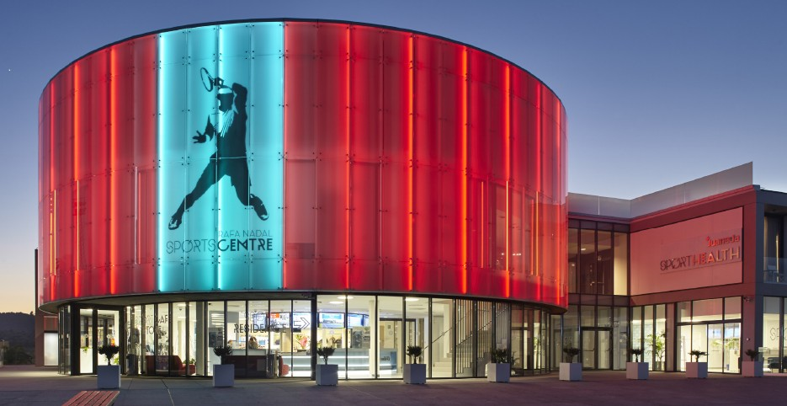

Players instruction: TEN-PRO at RAFA NADAL ACADEMY by movistar, 18-24 March 2019

1. Dress code is applicable. Mind the correct tennis wear.

2. Warming up for 5 minutes.

3. Clearly indicate when a ball is out of play. Play fair and only grant the ball when you are certain that it is over the line.

4. The server loudly shouts the current score of the game before the start of the service.

5. Update the scoreboards from top to bottom. So work towards the set.

6. Mind the breaks (20, 90 and 120 seconds, no break after the first game in a set).

7. All matches will be played for 2 won sets, a tie break will be played with the score at 6-6
By the score 40:40 (deuce) Sudden Death Point will decide it winner of gem, the returner chooses the side.

8. On-Court coaching:
On-Court coaching is allowed during the tournament (in the practice this means coach or parent is allowed to come on court during a changeover once per set, only at the end of a set, maximum of 2 minutes).
For the rest of the match verbal or gesticulated coaching during the match is not permitted and can lead to violation of the rules (SPS: violation of the rules, coaching outside On-Court coaching time).

9. Toilet break: you are entitled to 1 toilet break, to be taken after the set (reasonable time span) and only with the permission of the supervisor. During the match you are not allowed to have a toilet break because you will not be able to be back in time. When you decide to go "in your own time" after all, you run the risk of violation of the rules (by exceeding the time limit) due to unreasonable delay.
Note: do not make it a habit to have a toilet break after the 1st set. This can work to your disadvantage. Visit the toilet before the game!!

10. Repeated (obvious) view errors will be penalized as unsporting behaviour. Vigorous steps will be taken against this.

11. Please mind foot faults. Persistent foot faults at 1st service -> fault ... At 2nd service -> point loss..

12. Bouncing the racket is not permitted and can lead to violation of the rules. (SPS: violation of the rules, misuse of the racket).

13. Hitting away the ball angrily is not permitted and can lead to violation of the rules (SPS: violation of the rules, misuse of ball).

14. Intimidating the opponent (clenching one's fists and suchlike) is not permitted. First time will lead to a soft-warning, after that SPS can be applied due to unsporting behaviour.

15. Balls will be ready for each game. Players will immediately ask back their balls when they have rolled away (if the game on the court concerned has stopped).

16. The TEN-PRO management is authorized to make all the necessary changes above-mentioned in order to maintain the tournament successfuly.

17. Taking part at TEN-PRO at RAFA NADAL ACADEMY by movistar is an honor and privilege! When you have come this far, you hold the position to promote the tennis sport. Please demonstrate this in a positive way!

18. Finally, we wish you a pleasant and fair tournament.

TEN-PRO Team

