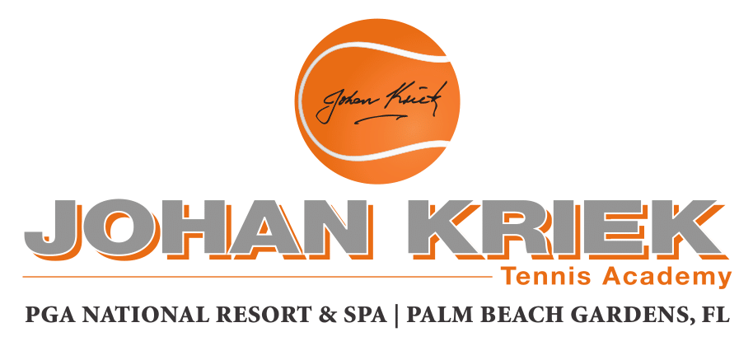

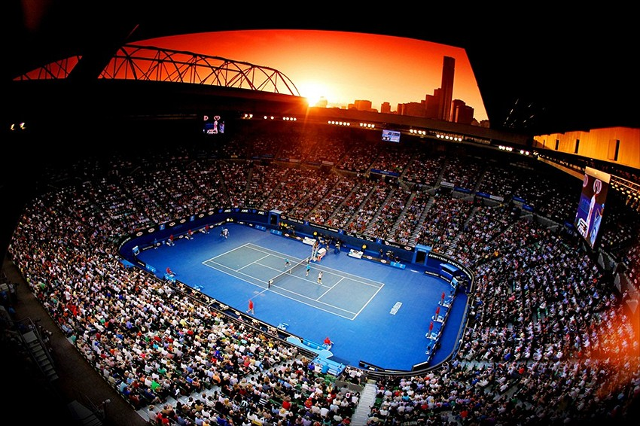

REGISTRATION FORM: JOHAN KRIEK by TEN-PRO Global Junior Tour

Name of player :
Boy/Girl :
Date of Birth :

Representing the country :

NOTE: Registration for participating in two categories is possible in that case we guaranteed 8 matches! (in your own category plus one EXTRA older age category) * See regulations

Please indicate : Play in one or in two category ………….

Please indicate : You are staying in PGA Hotel or somewhere else .................

NOTE: STAY AT PGA HOTEL AND PLAY THE TOURNAMENT FOR FREE!

If you are staying at PGA Hotel (with a minimum of 5 nights and only by direct booking through Ten-Pro) then is your entry fee FREE! * for participation in one category. For registration in the second category you have 10% discount.
Note 1: If you are staying at PGA Hotel but is not booked through Ten-Pro then for you also apply standard entry fees.
Note 2: In case of multiple participants staying in one/same PGA guestroom then is your entry fee FREE only for one player (For registration in the second category you have 10% discount) For all other players from the same PGA guestroom apply standard entry fees.

Tel. Number :
Mobile nr. :

E-mail :

Name of tennis club :
E-mail of tennis club :
Name of your coach :
E-mail of your coach :

Favorite player:

You play with (racket) :

Training hours weekly :
Private training :
Training in group :
Physical training :
Mental training :
Current ranking my age :
Main results :
Your greatest wish :

Certificate of health :

By sending this registration form we declare that we have read and accept all the terms and conditions of TEN-PRO Global Junior Tour unconditionally and also that our son/daughter/player ............................................... is in perfect health and has the permission of his/her parents to take part in this tournament. We also agree that Ten-Pro have permission to make free use of all photos and films of our son/daughter/player (For Social Media of TEN-PRO or by partnership website).

TO COMPLETE THIS APLLICATION YOU ARE REQUIRED TO ENCLOSE A COPY OF YOUR ID OR PASSPORT!

To participate, please fill in the enclosed form and return it by e-mail to proglobus@live.nl f.a.o. Goran Novakovic

TEN-PRO Global Junior Tour / Mob.: +31 (6) 22 11 88 57 / Website: www.ten-pro.net / FB: Ten-Pro Global Junior Tour / Insta: Ten-Pro Global Junio Tour / Twitter: @TenProGlobaljr

