Powered by

We have selected a number of hotels and overnight accommodations for you. All of them offer special prices/packages for Dutch Bowl players/parents and coaches. Please visit their websites for more information about pricing and availability (See Travel and Stay).

Special prices for tournament participants (players, coaches and parents).
Please apply under the heading "Dutch Bowl ".

Official players hotelde RoodeLeeuw in Terborg
This hotel is the official players hotel (very near to the tennis courts) and offers special prices/packages for Dutch Bowl players/parents and coaches.
For reservations call: 0031 (0)315 397139 or send an email to info@deroodeleeuw.com.
Please refer to Dutch Bowl. (www.deroodeleeuw.com)

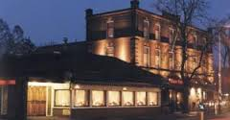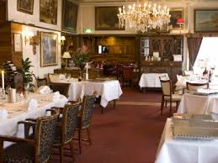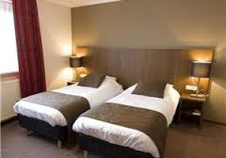

Hotel de Lantscroon in ‘s-Heerenberg
This hotel offers special tournament packages/prices for players of the Dutch Bowl.
Please refer to Dutch Bowl. (www.hoteldelantscroon.nl)
For reservations call: 0031 (0)314 664 157 or send an email to lantscroon@online.nl

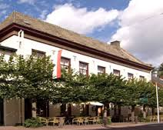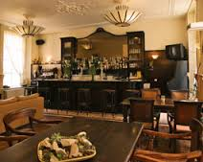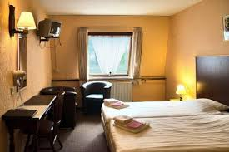

FOR CHEAP AIRPLANE TICKETS PLEASE GO TO: www.skyscanner.com

Tournament date: 20th to 26th February 2017.

Tournament registration deadline: February 13rd 2017 at 14.00 o’clock.

Tournament contact: proglobus@live.nl

Tournament website: www.ten-pro.net

With kind regards,

Goran Novakovic,
Tournament Director

Goran Novakovic | Director of Ten-Pro Global Junior Tour | Mobile: +31622118857 | proglobus@live.nl | Skype: g.novakovic1 | www.ten-pro.net |Powered by Wilson

With more than 2.650 selected players from 98 countries of which 1.950 participants already played a guaranteed minimum of 4 matches per tournament at their tennis level, the Ten-Pro Global Junior Tour is one of it’s kind that also was used Live Streaming and video analysis during the tournament. The Ten-Pro Global Junior tour has become one of the largest and most strongly represented series of tournaments in the world for players born in this age!

