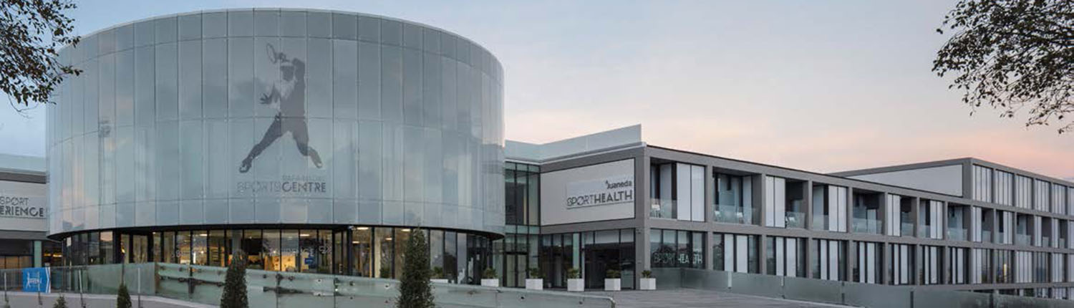

INFORMATION PACKAGE

GENERAL INFORMATION

Ten-Pro Global Junior Tour – RAFA NADAL ACADEMY by MOVISTAR

Date: from SATURDAY 25th till FRIDAY 31st of March 2017
Location:Rafa Nadal Academy by Movistar, Manacor, Mallorca, Spain.

For contact, registration and all the necessary information regarding the tournament, please contact: Goran Novakovic – proglobus@live.nl – 0031 6 22 11 88 57

For training camp, hotels, transport and any other useful information, please contact: reservations@rnsportscentre.com – 0034 971 171 680

TRAINING CAMP

The training program is personalised and tailored to the characteristics of each student, using the methodology that Toni Nadal has created and developed according to his experiences with Rafa Nadal.

Please download ONE WEEK PROGRAM – ENG
At http://www.ten-pro.nl/nadal/information-package/

RAFA NADAL ACADEMY BY MOVISTAR

“It’s a very special project for me, through which I hope to convey everything that I have learned during my development as a person and as an athlete, as well as the experiences that I have gone through during my career as a tennis professional.”Rafa Nadal
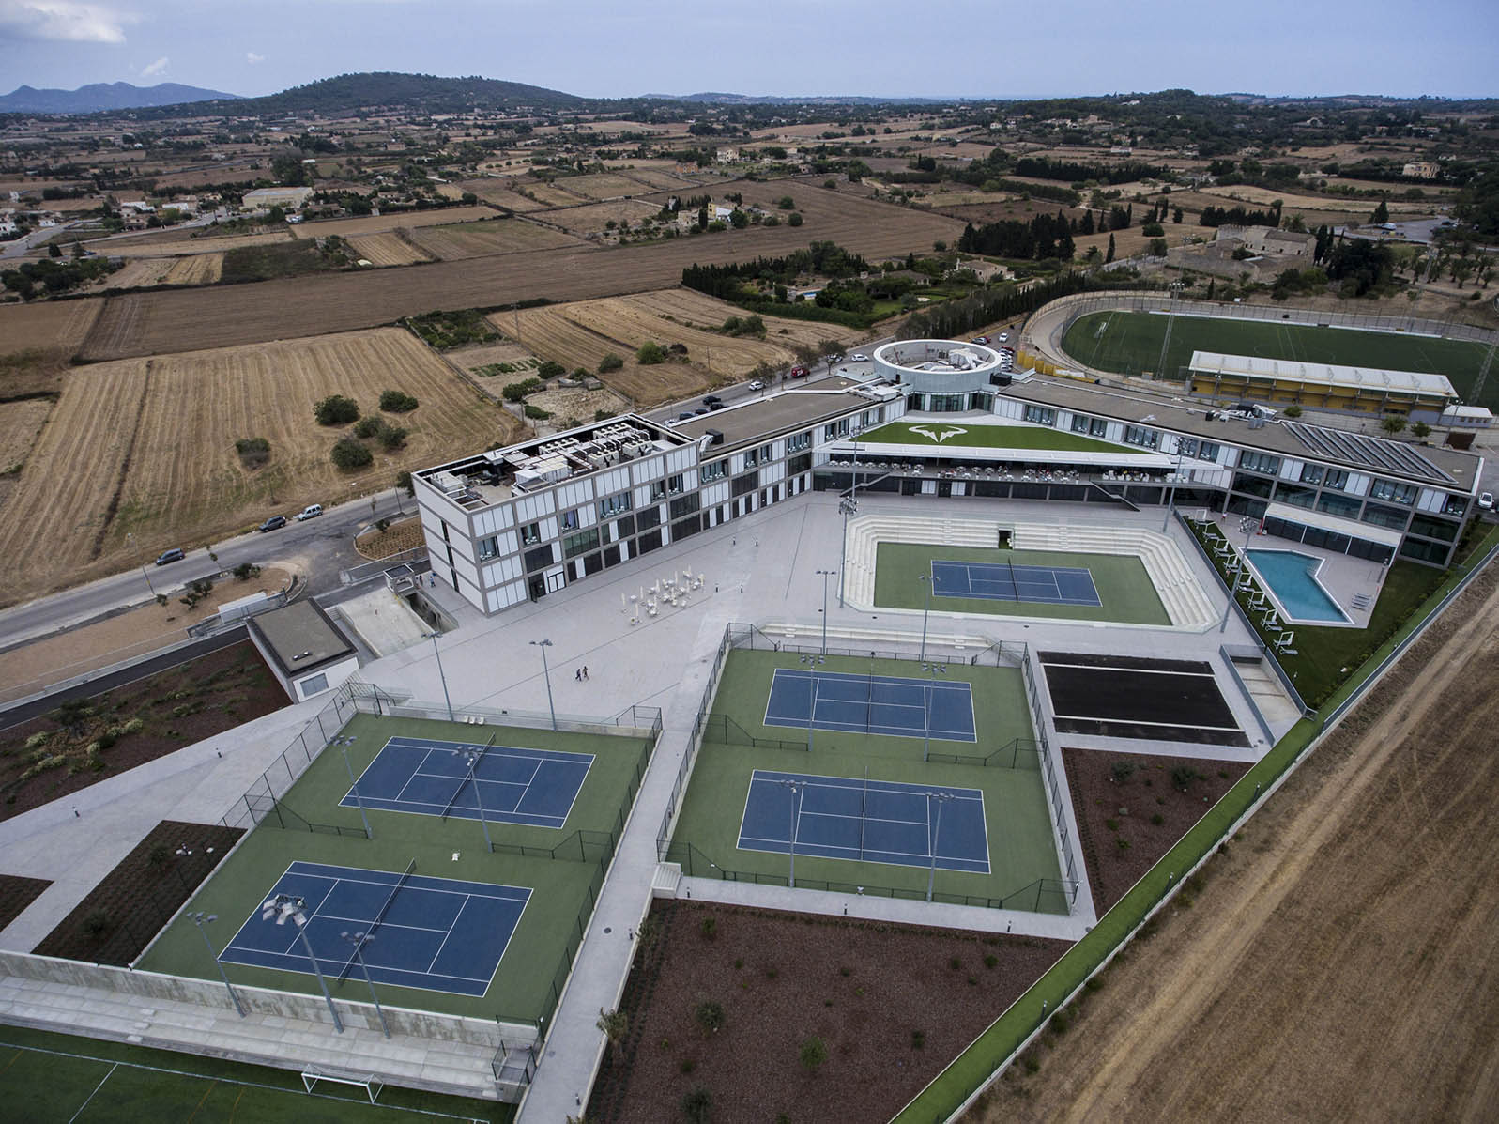
Rafa Nadal Academy by Movistar opens its doors for young players to train with the method that has led Rafa to be number one, with guarantees of being surrounded by the best coaches and the best technical team in the tennis’ field. All this in a space thought for them, in an integral campus with the best facilities and high technology applied to sports.

Maximize your strengths; minimize your weaknesses with the training techniques of Rafa Nadal and his team.

Rafa Nadal has transformed his training base into a high-performance academy where, together with his team, he will develop young tennis players.

Located in Manacor (Mallorca), Rafa Nadal’s home town, the Academy combines tennis and education so that students can continue their pathway to professional tennis without having to neglect their academic studies.

The Academy has its own training system based on the experience acquired by Rafa and his technical team during his years on the ATP circuit, and including the values that have been fundamental to his achievements and success.
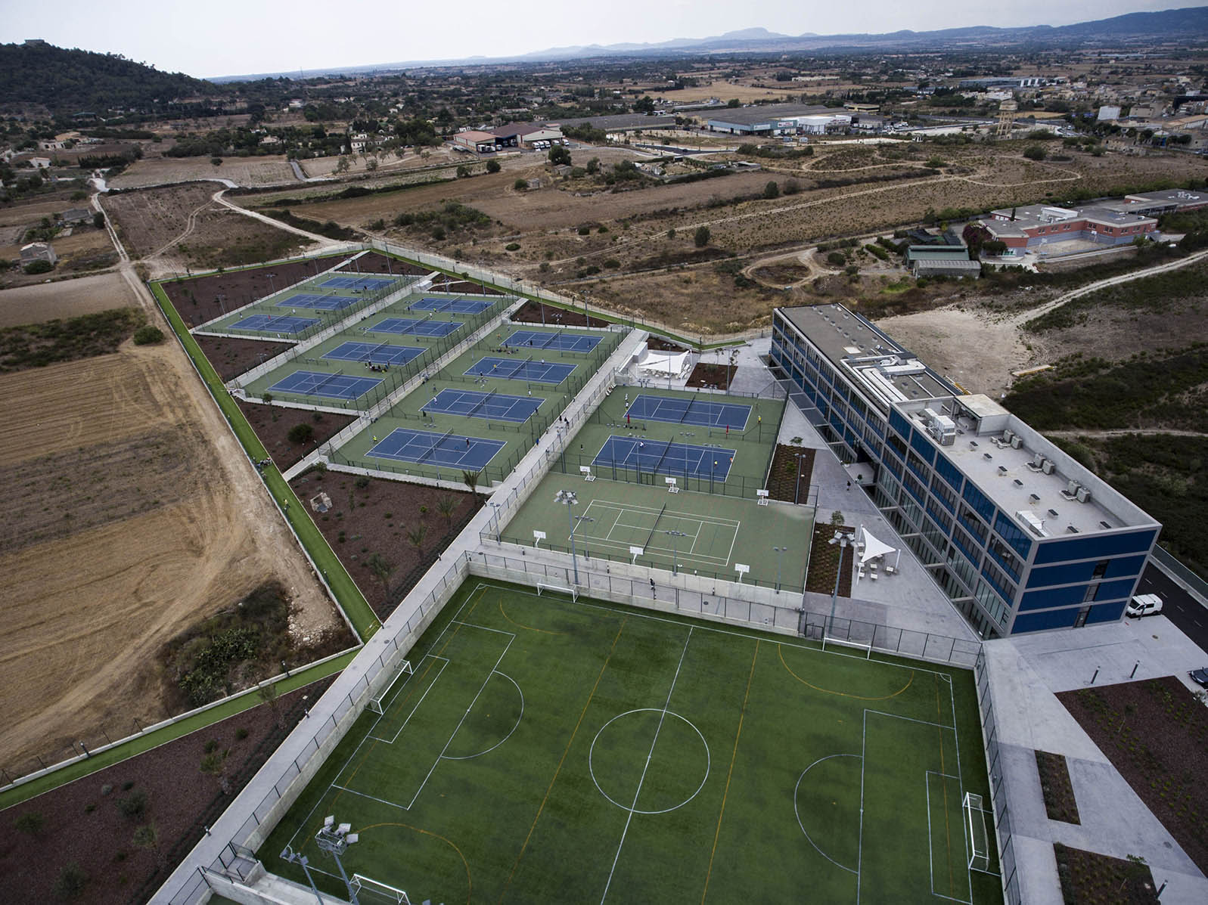

The Academy’s team is comprised of a group of experienced coaches, directed by Toni Nadal, and by other professionals that have accompanied Rafa throughout his sporting career. The team in which he has always trusted is actively involved and has an important role at the Academy.

OBJECTIVES

To maximise the potential of every player, so that they have the opportunity to become a professional tennis player without having to abandon their studies.

To combine high performance tennis with academic excellence so that those students that wish to can continue their sporting and academic education can benefit from the best scholarships to universities in the USA.

To educate people through sport, positively influencing the personal development of students through the promotion of certain values.

VALUES

Rafa Nadal’s achievements are the fruit of values that have been conveyed to him by his team throughout his development and these will also be essence of the Academy, taught to the students in all areas.

Values such as hard work, discipline, overcoming adversity, honesty, friendship, commitment, humility and respect, amongst others, are synonymous with the Academy and are the pillars on which we base the education, training and overall development of the students.
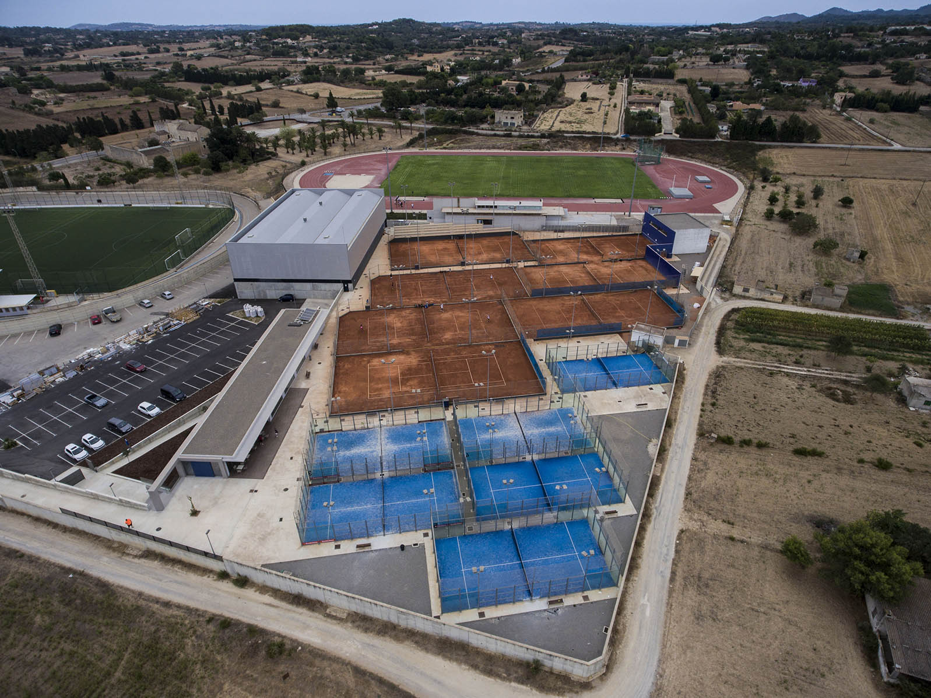

Order is another intrinsic value on which we place a vital importance in the daily life at the Academy. Our students must be responsible for maintaining order, while demonstrating daily commitment to attitudes of good behaviour, tolerance and coexistence.

Overview

The brand new sporting facilities created by the Rafa Nadal Academy are equipped with the latest technology and include:

• Supervised residency exclusively for students
• American International School
• 26 tennis courts of different surfaces (Clay, Greenset), outdoor and indoor
• Fitness Centre with all the latest equipment
• 2 swimming pools; one outdoor and one indoor
• Mini-football pitch (Football 7)
• Regulation multi-sports court
• 7 padel courts
• Restaurant and café bar
• Pro Shop
• Clinic, specialised in sports medicine, physiotherapy and nutrition.
• Gardens

The Rafa Nadal Academy is a first-class campus, which allows young people between 12 and 18 to be educated academically in American International School while training to become professional tennis players. In addition, the Academy has a program for students who do not wish to dedicate to professional tennis, so they can get scholarships at universities in the US and continue competing.

Tennis Programs

Annual course, which combines academic training with the preparation of high-level tennis. Lasting from September to June, the training program is personalised and tailored to the characteristics of each student, using the methodology that Toni Nadal has created and developed according to his experiences with Rafa Nadal.

The program includes:

17 hours of tennis training per week
8 hours of physical fitness training & kinesiology per week
Academic studies at the American International School of Mallorca
Accommodation at the supervised residency within the Academy
Breakfast, lunch, snack and dinner
Medical attention, physiotherapy and nutritional care
In-competition coaching
Medical checks and strength/conditioning tests
Psychological assistance and mental training
Video analysis
Leisure activities at weekends

Rafa Nadal Academy also offers three other types of programs:

Monthly program: 4 weeks (September to June)
One week program: 1-3 weeks during summer (September to June)
Tennis Summer Camp: 1 or more weeks during summer (June, July and August)
All this in the hands of the best professional of tennis, enjoying the best tennis in the sports facilities and the latest technology applied to sports to improve in and out of the tennis court.

For more information please visit: https://www.rafanadalacademy.com/en/web/web-rafa-nadal-academy/programs
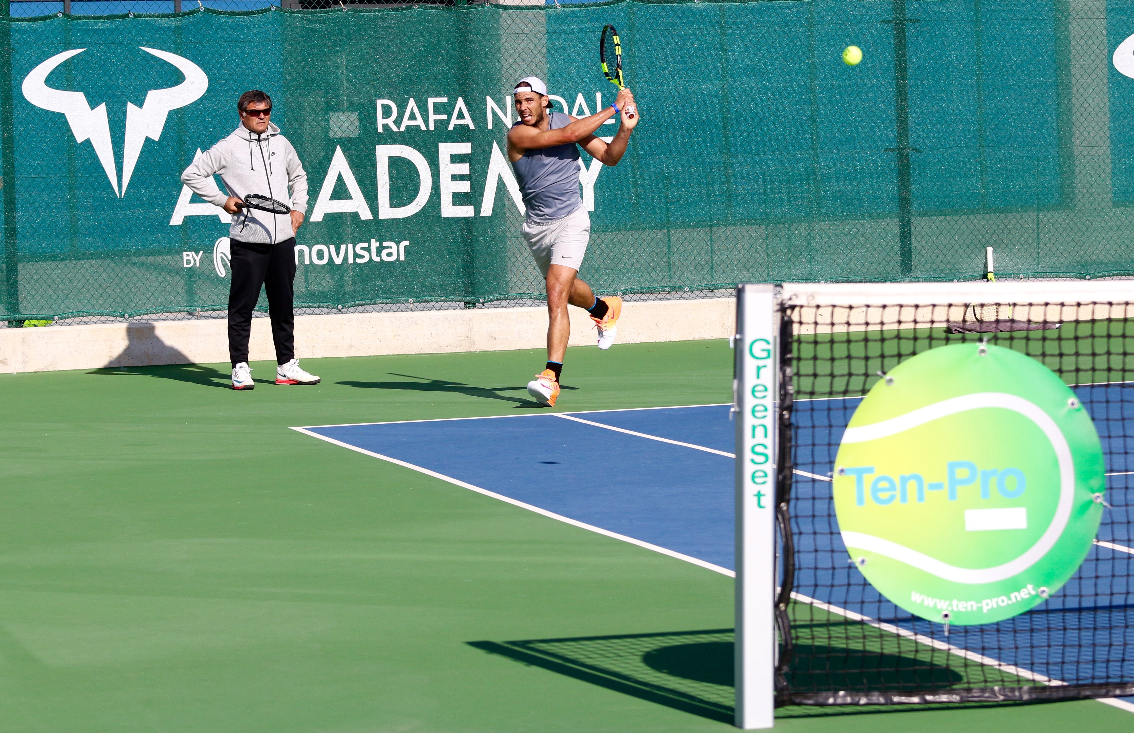

Location and Site

The Academy is located in Manacor, on the east of Mallorca, in natural surroundings just ten minutes from the sea and 30 minutes from Palma’s international airport. Mallorca is a Mediterranean island that enjoys a temperate climate, ideal for playing tennis all year round.

The Rafa Nadal Academy by Movistar is part of the Rafa Nadal Sports Centre and boast a beautiful complex with everything a player or coach would need.

Besides the services of Rafa Nadal Academy by Movistar mentioned above the facility further includes:

· Fitness Centre. 3.000 sq with the lattest Technogym equipment.
· 25m long indoor swimming pool
· Over 100 studio fitness classes per week
· Spa and Wellness Center
· Sports Health Center and Clinic
· Adult Residence inside the facilities (65 double rooms)
· Restaurant & Bar
· Sports Shop
· Sport Xperience by Rafa Nadal. A Sports Museum with the lattest technology.
· American International School of Mallorca. An international school.
· Shop corner with products of Rafa Nadal Foundation

For more information please visit: https://rnsportscentre.com

OFFICIAL PLAYER ACCOMODATION.
RAFA NADAL SPORT RESIDENCE

67 double rooms within a large sports complex and spectacular state-of-the-art facilities.

26 tennis courts with different surfaces, both exterior and interior,
7-a-side soccer pitch,
multipurpose sports courts,
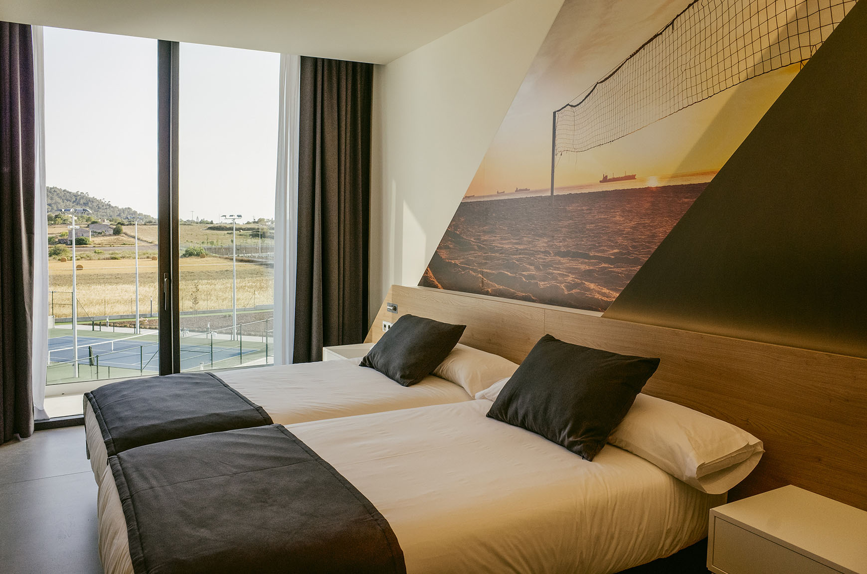
outdoor swimming pool and 25m indoor pool,
10 paddle courts and an athletics track makes RAFA NADAL SPORT RESIDENCE a unique space in which to live your passion for sport.

RAFA NADAL SPORT RESIDENCE gives you the opportunity to live a 360 sport experience.

RATES:

Double Room (Bed & Breakfast): 110€ + local taxes
Max 3 people per room. Extra bed: 40€ (with bed & breakfast)

Double Room FULL BOARD ( Breakfast, Lunch and Dinner): 150€ + local taxes
Max 3 people per room. Extra bed: 60€ (with full board)

Make your reservation: reservations@rnsportscentre.com (subject: TENPRO)

RESTAURANT/BAR – SPORT CAFÉ

During the tournament there is lunch and dinner available, with a daily buffet service . Price to be confirmed.

There will also be an à la carte menu available.
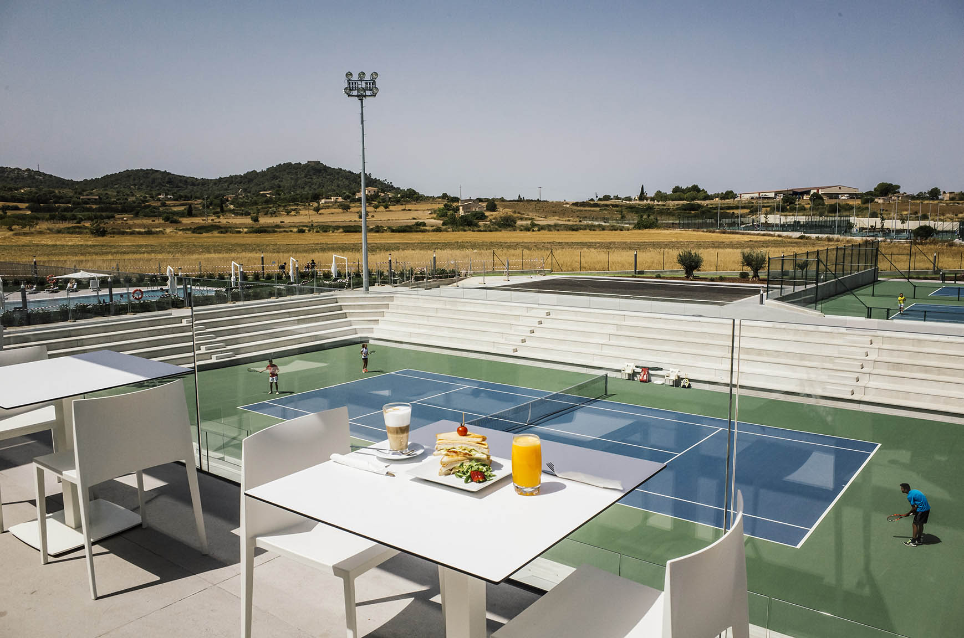
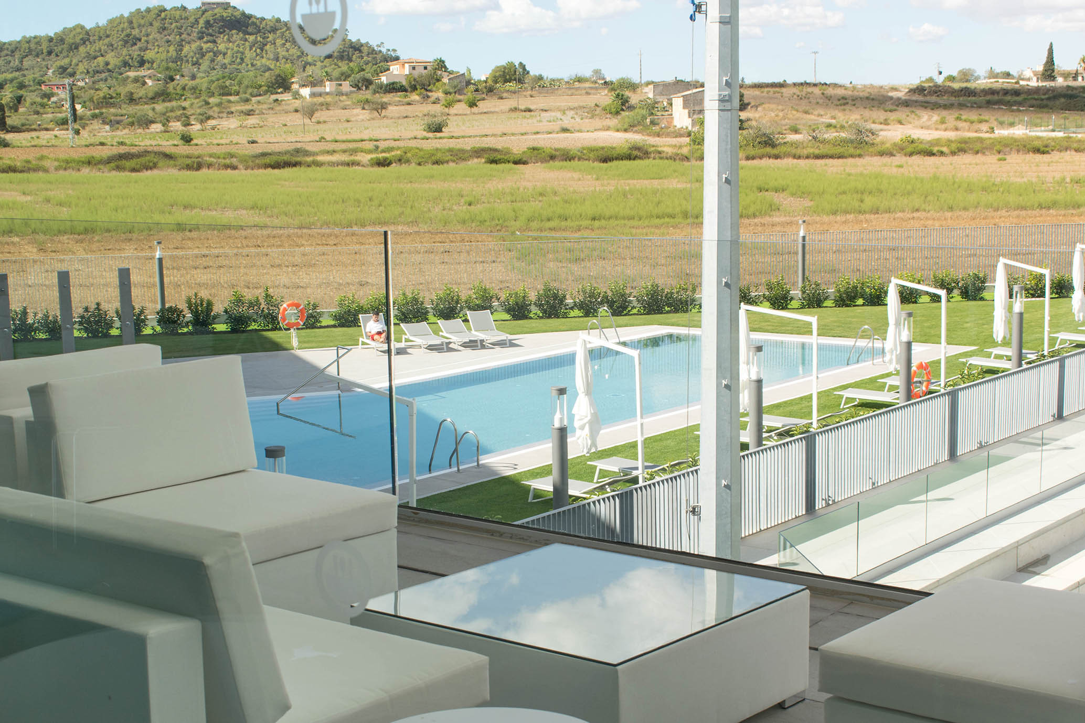

TRANSPORT

The Rafa Nadal Academy by Movistar is located in Manacor, just 30 minutes from Palma’s international airport.

Contact reservations@rnsportscentre.com for special shuttle and private transfers services.

FITNESS CENTER & SPA
Only available for +16 years old.
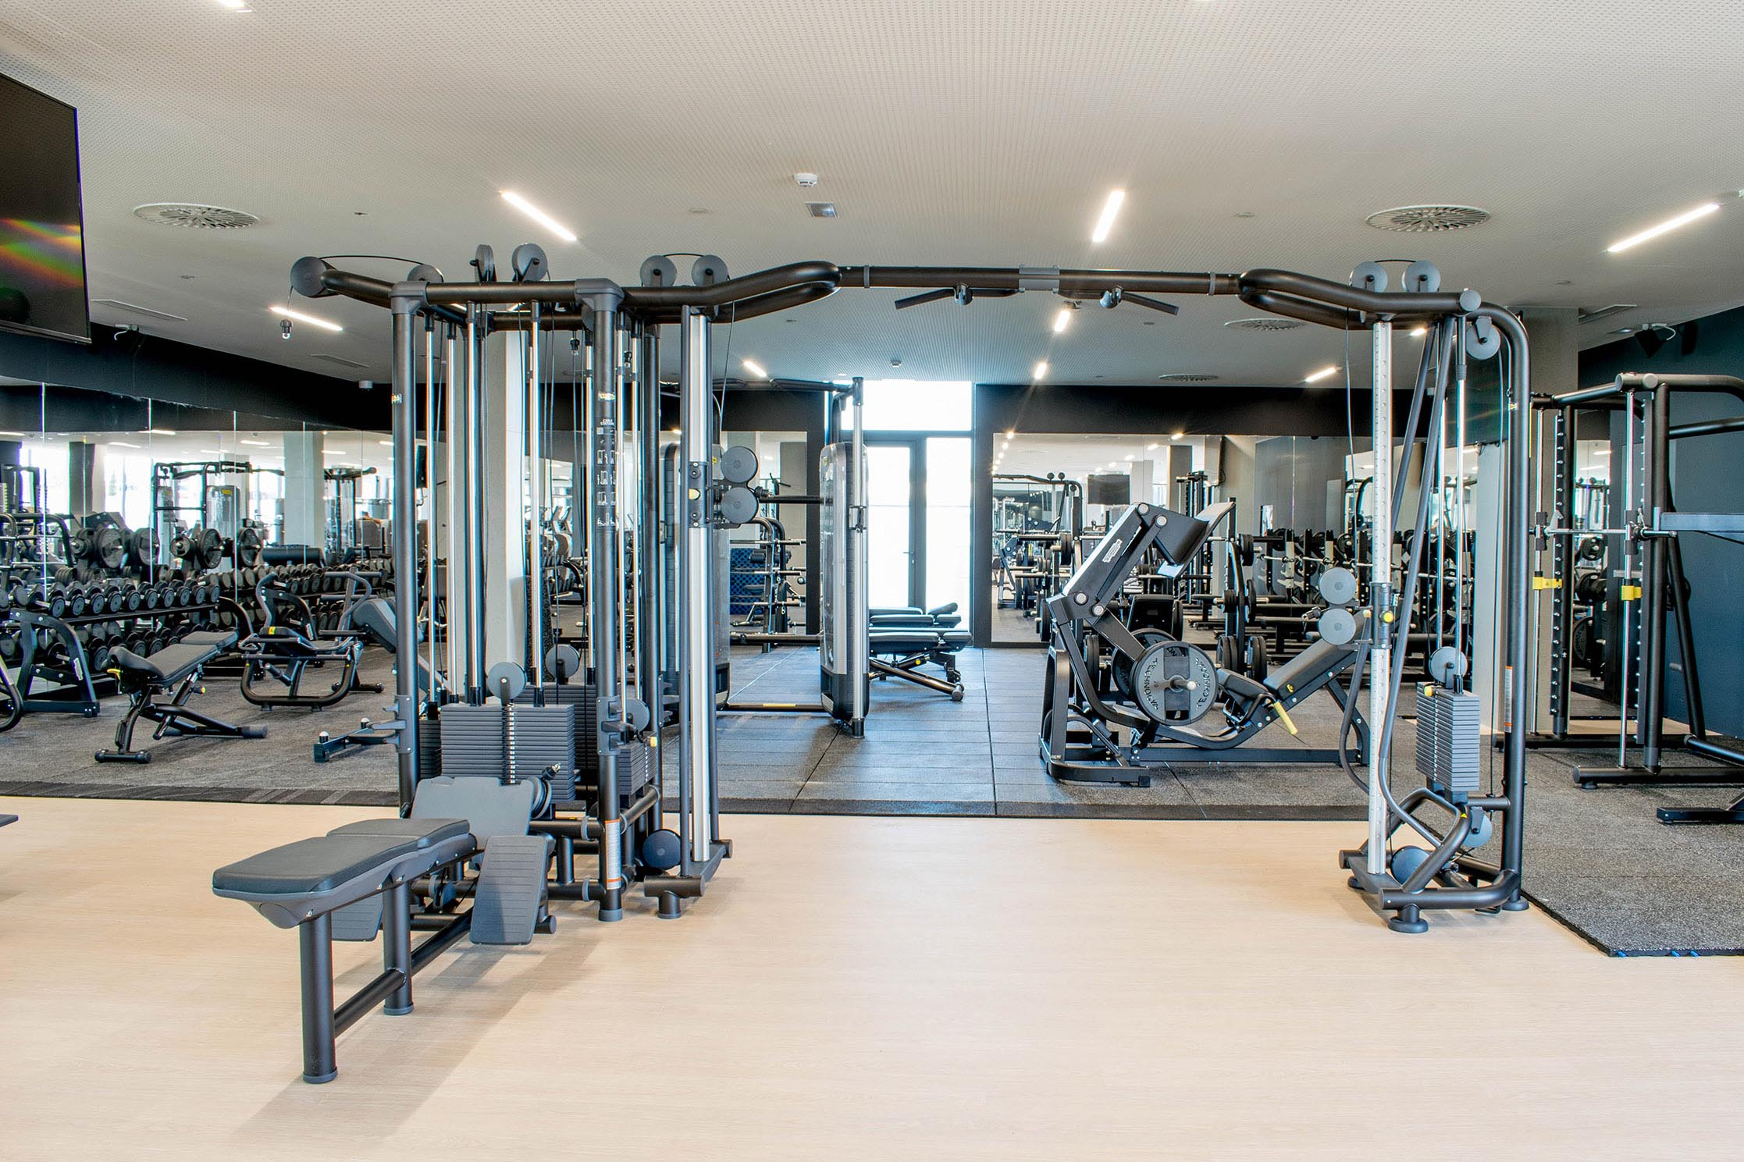
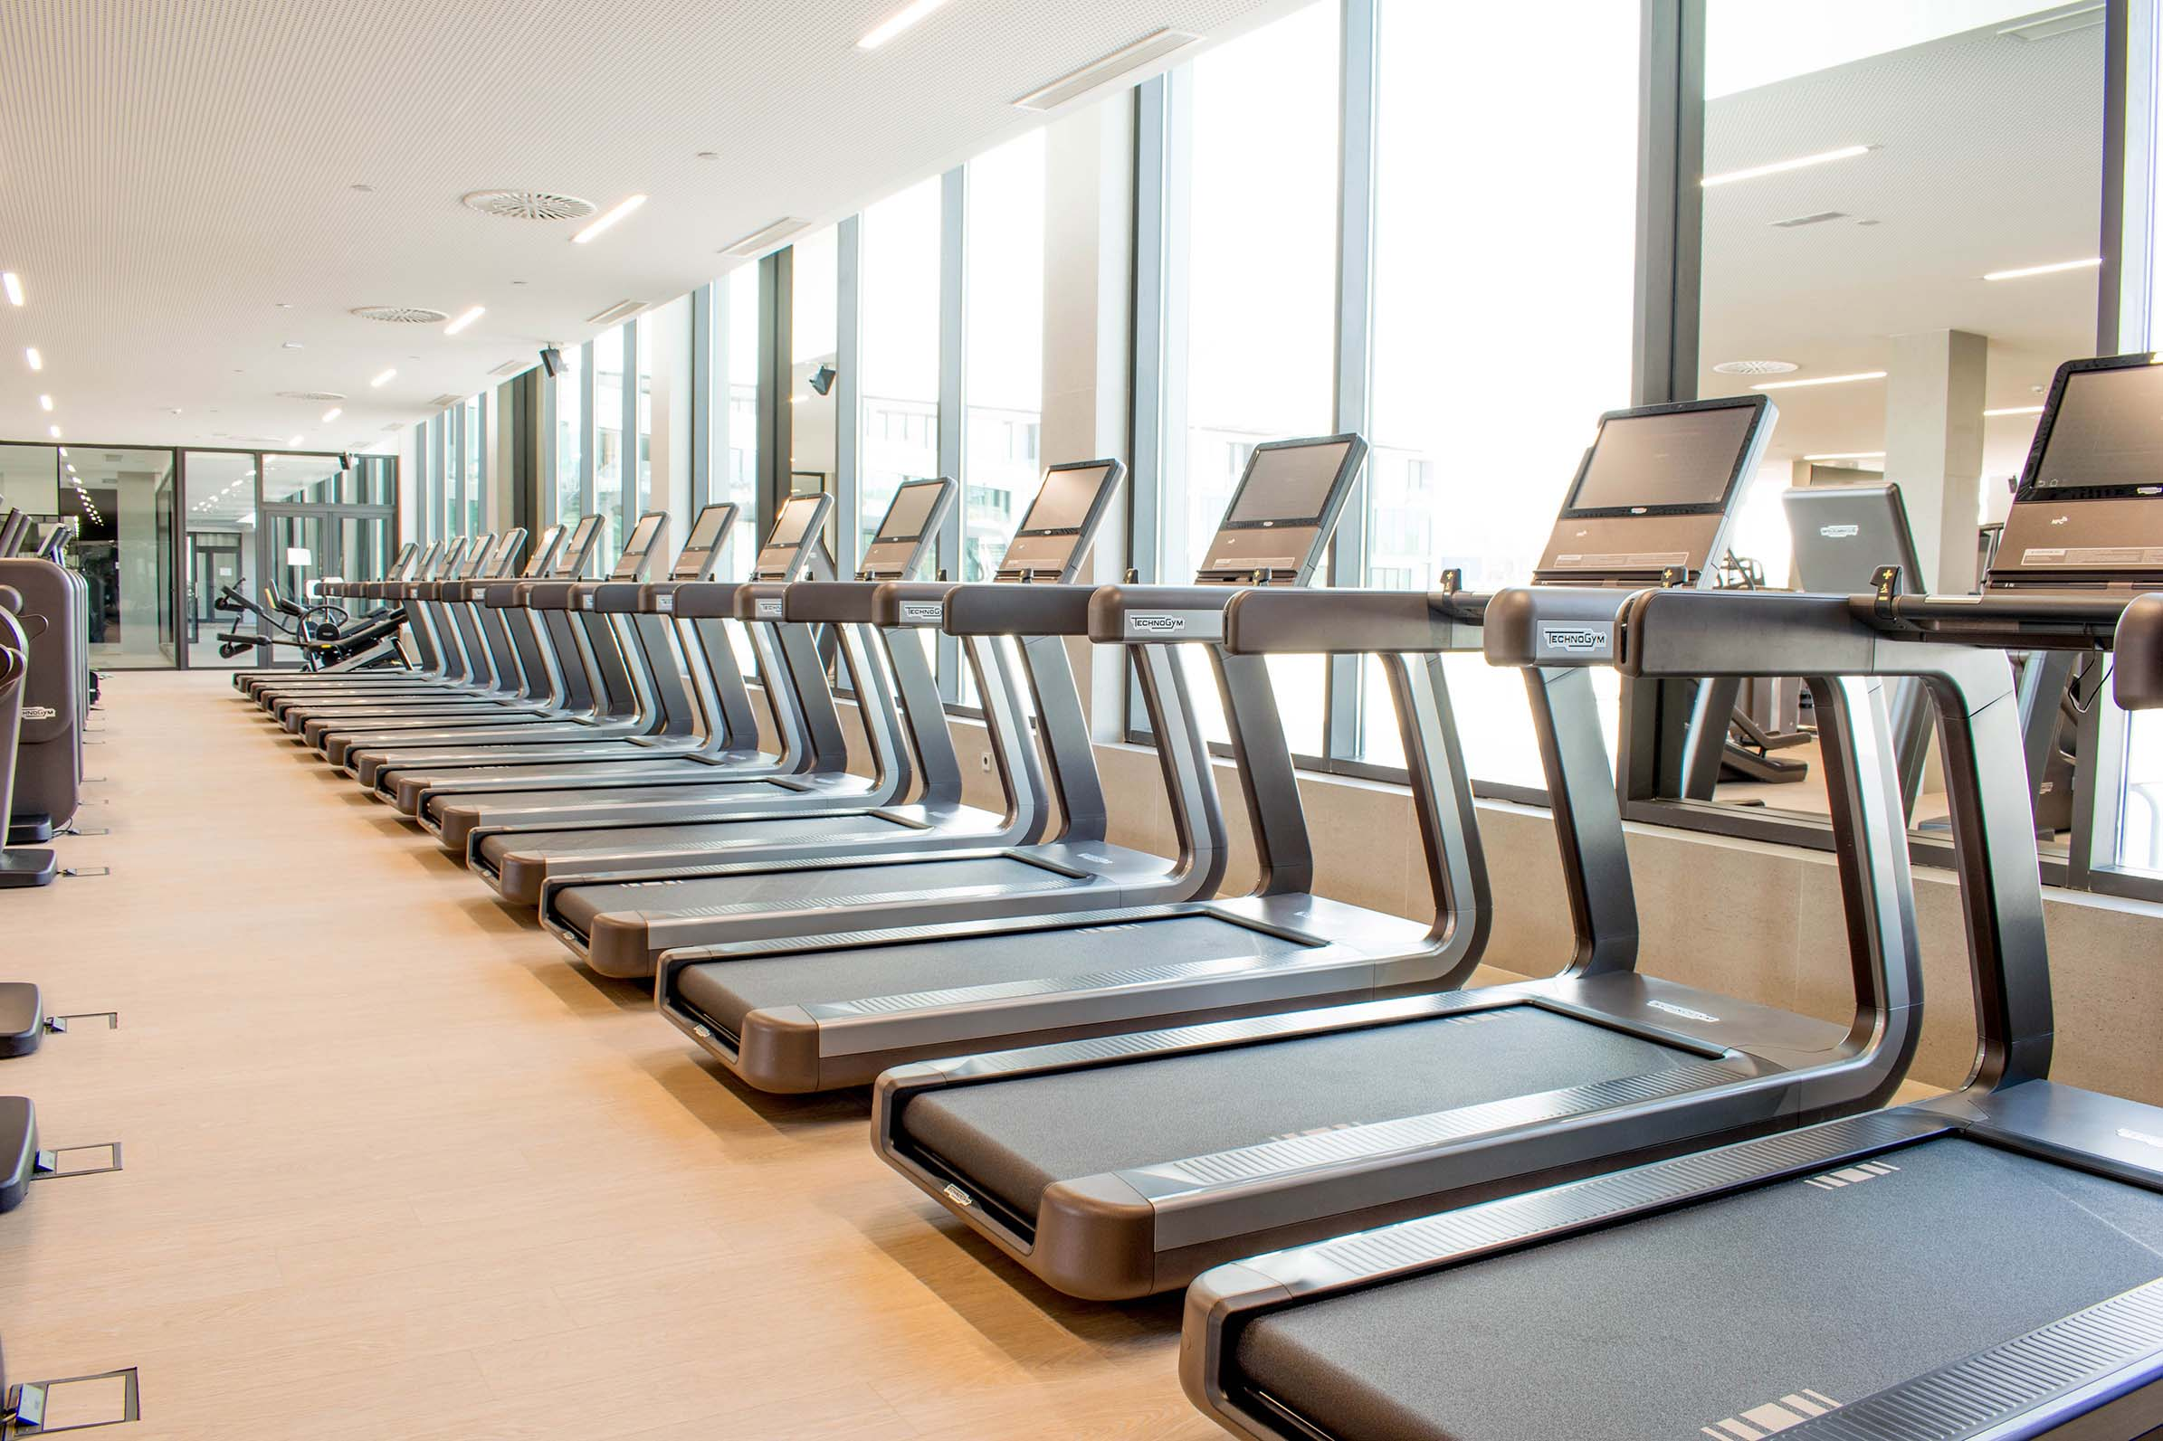
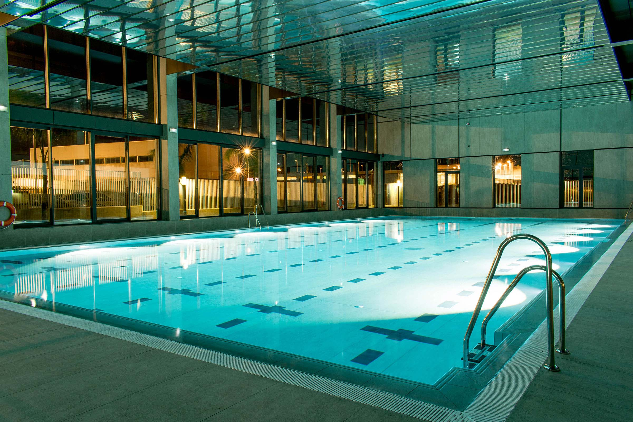
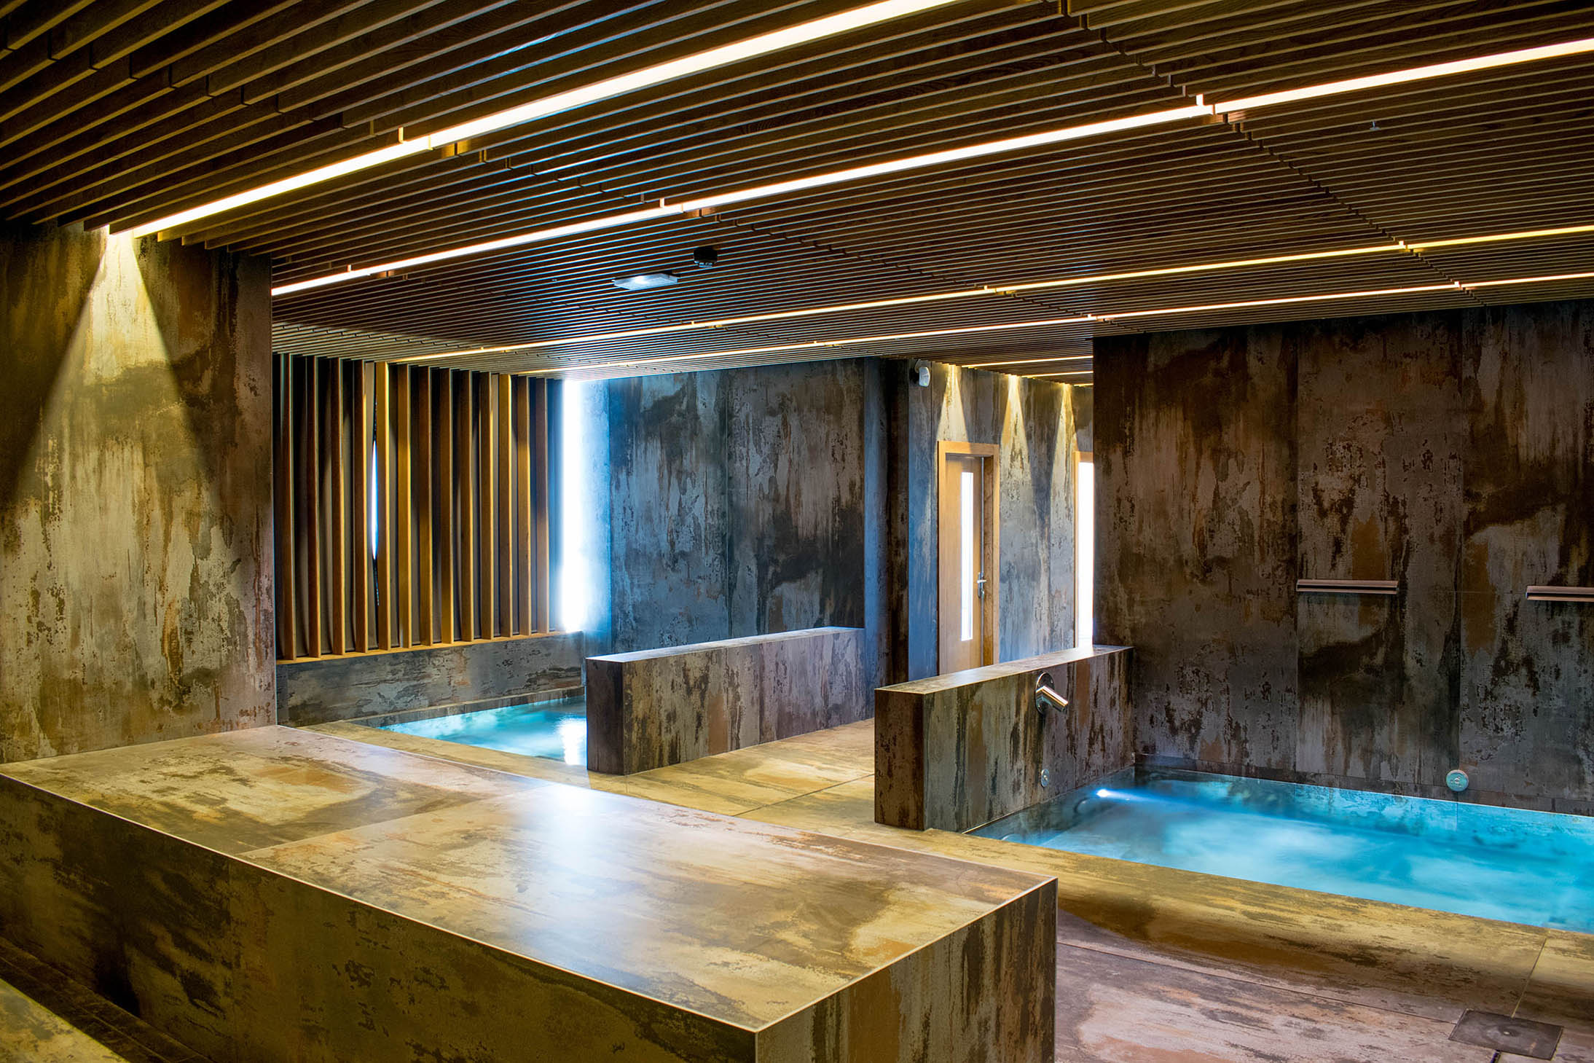
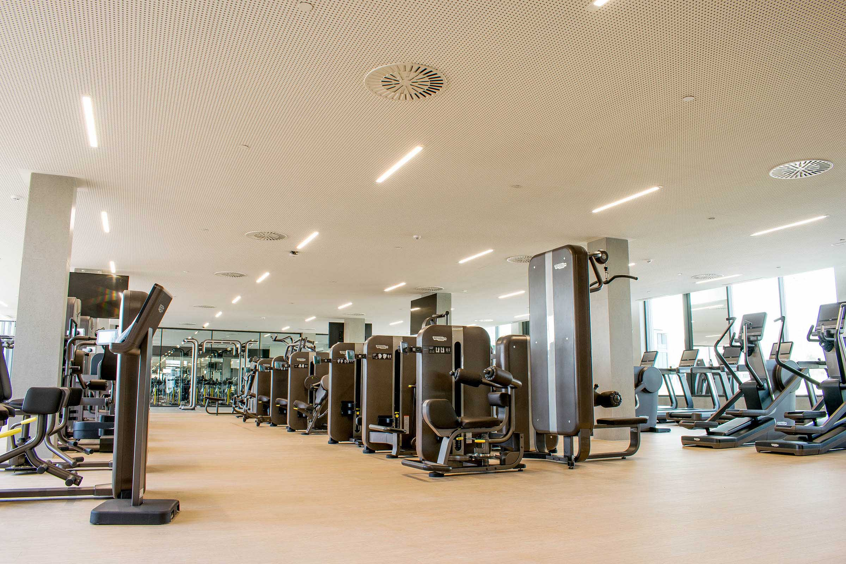

A 3.000 sq fitness center& SPA

Over 100 studio classes per week,

The latest fitness equipment provided by Technogym,

Indoor 25m swimming poo

The best trainers for a perfect workout.

RATES FOR GUESTS AT THE RAFA NADAL SPORTS RESIDENCE:

- Indoor Swimming Pool Entrance: 5€/day
- Fitness Centre Entrance. 5€/day
- Fitness Centre and Swimming Pool entrance: 10€/day
- Spa Entrance: 20€/day
- Premium Entrance (all areas included): 25€/day

FOR MORE INFORMATION, PLEASE CHECK:
Rafa Nadal Sports Centre Brochure
https://www.dropbox.com/s/3mda0bxlt2q8h42/CATALOGUE%20RNSC%20ENGLISH-Reducido.pdf?dl=0

JUANEDA SPORTS HEALTH

RAFA NADAL SPORTS CENTRE offers visitors an unprecedented combination of sports and health. To ensure the services offered are of the highest quality, there is a medical center within the facilities, which is operated by the JUANEDA GROUP.
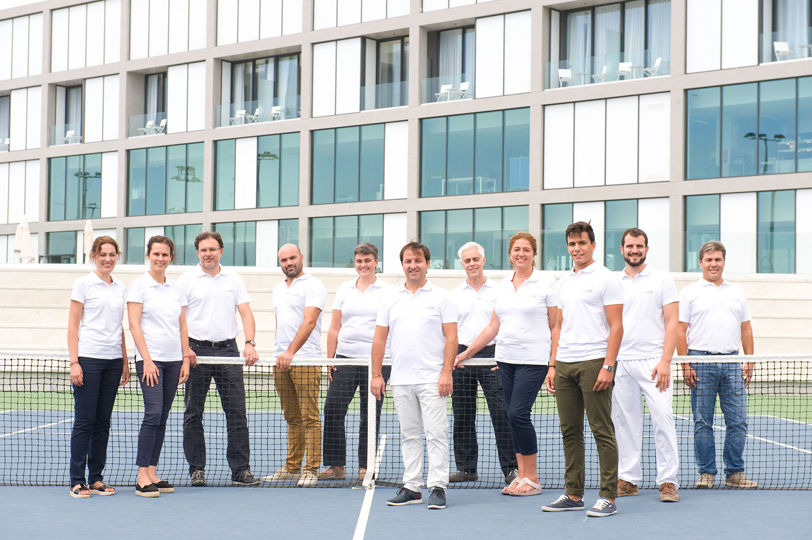

JUANEDA SPORT HEALTH is a clinic specializing in sports medicine that provides a medical service to students at Rafa Nadal Academy by Movistar; to Sport Time clients; to guests at Rafa Nadal Sport Residence, and others.

The clinic, however, not only has specialists in sports medicine, but offers a broad portfolio of healthcare services for all visitors.

All of this is achieved through the work of the professionals who are integrated within the healthcare network, recognized for its dedication, personalized service, teamwork and continuous innovation.

