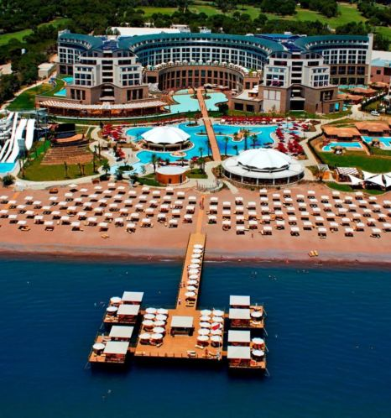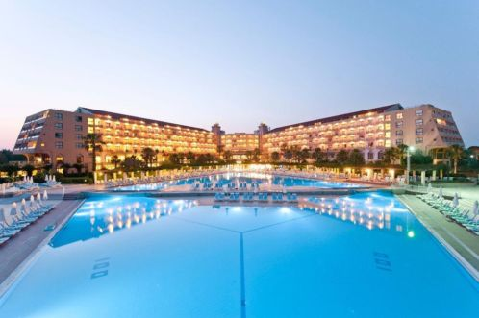

HOTEL RIU KAYA BELEK , 5 *****– ANTALYA, TURKEY

Address: Üç Kum tepesi Mevkii / Belek – ANTALYA – TURKEY
Ten-Pro and GD Tennis Academy are proud to welcome players from all around the world to our GD World Junior Tennis Masters 2015, which will take place at RIU KAYA BELEK - Antalya.

The tournament will be held at the RIU KAYA BELEK Hotel which has wonderful facilities and more than 18 tennis courts. The tournament is also a good opportunity for the players’ parents and coaches to relax and enjoy at this all-inclusive, 5 star hotel.

RIU KAYA BELEK, with its interesting architectural style, is a recommended holiday resort which is set within well-maintained gardens and courtyards. As well as its air-conditioned main restaurant, there is also a Beach Restaurant and a Panorama Restaurant (a’ la carte) available to its’ guests. On the hotel premises you will find a TV room with a library, a Turkish cafeteria as well as a shopping centre with a boutique, a jeweller’s shop, a gift shop and a leather goods shop. Other services and attractions offered at the RIU KAYA BELEK include a big swimming pool, chaise lounges on sunny terraces , an Aqua park, an Adventure Park, a Wellness & Spa Centre, a Fitness Studio, a beauty salon, various bars, an information stand, laundry service, night entertainment programs, a disco, as well as an open air disco, playground areas for children, children pools ….. and much, much more.

For Hotel Reservations Please Contact:
Phone: 0090 532 375 98 23
Fax: 0090 212 2495161
mirac@gdtennis.com or info@gdtennis.com

FOR CHEAP AIRPLANE TICKETS PLEASE CONTACT CUSTOMER SERVICES AT info@gdtennis.com or see www.skyscanner.com

Special prices for tournament participants,(Players, Coaches and Parents)
Please apply under the heading "GD World Junior Tennis Masters ".

- Double Room: €55 per person /per night all-inclusive
- A third person in the room per day : €55 per person/per night all-inclusive ( if a child shares with 2 adults the price for the child will come at a 50% discount (€55 + €55 + €27,5 all-inclusive)

- Single Room: €82 per person /per night all inclusive

All-inclusive at the RIU KAYA BELEK Hotel
Breakfast, late breakfast, lunch, a snack and dinner are all served as an open buffet.

For all additional tournament information please see the website below:
http://www.ten-pro.net

Tournament Date: 02 October- 08 November 2015

Tournament Enrolment Deadline: Oktober26th 2015 at 14.00

Tournament Enrolment Contact: proglobus@live.nl

Tournament Director: Goran Novakovic

Tournament Contact Email: proglobus@live.nl

Tournament Web Site: www.Ten-Pro.net

Best regards,
Goran Novakovic.
Tournament Director.
Email : proglobus@live.nl (directly)
Tel. : 0031-6-22118857
Skype : g.novakovic1
Website : www.ten-pro.net
Ten-Pro Connecting talents!
Powered by Wilson and in partnership with: Mouratoglou Tennis Academy – France
MCB Tennis Foundation - U.S.A.
Base Tennis Academy - Germany
GD Sport Tennis Academy –Turkey
House of Tennis – The Netherlands

